|  |
| --- |
|  |



* **Jingyi Li**
* **Zijing Liu**
* **Jonathan Roselli**
* **Ao (Sophia) Tan**
* **Apurva Tawde**
* **Zinan Yang**
* **Yushan Cai**
* **Changpeng Cheng Yagna Ganesh**
* **Ryan Ferguson**
* **Yuguan Liu**
* **Tu Trinh Nguyen**
* **Junwei Wang**
* **Parag Paliwal**
* **Siddharth Chaudhary**
* **Vinod Balraj**
* **Xin Huo**
* **Yi Jin**

Drexel Office Of Research Project

BSAN-710-674 - FA 19-20 - Business Analytics Capstone Project

**FORECASTING DREXEL’s Research Awards and Expenditures**

|  |  |  |
| --- | --- | --- |
|  |  |  |
|  |  |  |

# Executive Summary

**Drexel** is a world-class comprehensive research institution committed to use-inspired research with real-world applications. Annually, the university's research activities result in more than **$123 million** in annual **Expenditures** for **Sponsor**ed projects, thousands of scholarly and creative works, more than **100 invention** disclosures as well as over **40 U.S. patents**.

**Drexel** Research's business goal is to raise the **Drexel**'s research **Expenditures** in order to improve the **Drexel** University ranking in the U.S. The project goal is to predict **Drexel**'s research **Expenditures** and **Award**s for **2020-2024** by **respective models** which will include both causal and time-series factors based on records from **2009-2019**. This will essentially help the Office of Research to take action about **Drexel**'s national ranking. Also, the project will give more insight into the relationships between the **Proposals**, **Awards**, and **Expenditures**.

|  |
| --- |
| ***“The Office of Research invests in the future, enabling research advances to sustain Drexel's reputation as a preeminent university.”*** |

This is a real dataset collected from a **Drexel** Office of Research, which includes the **Proposals**, **Awards**, and **Expenditures**. The report consists of data analysis, exploration, and methods with evaluation. A key to unlocking the full predictive power of our forecasting model is structuring the data correctly and understanding the relationships between the variables. Methods of building the prediction model include **Clustering by college, time series ARIMA model**. The relations between **Proposals**, **Awards**, and **Expenditures** are found by finding the **Hit Rate** calculation, **Sponsor** preference, etc. Model performances were compared based on two criteria: **convenience** and **accuracy** (Akaike information criterion and the residual sum of squares). Through this report, there is going to be an explanation of our data analysis method, prove its accuracy and recommendation.

# Introduction to the Business Challenge

## Business Goals

Every year, there are thousands of Proposals submission to the Drexel Research Funding. The funding environment can be challenging as most of the Proposals might not get accepted on their first submission. Obviously that there is competition among all the funding as they would like to raise as much as possible for their project. Also, from the situation provided by Drexel Research, the department has been dealing with many human errors, and the three data sets are not completely clean. This would highly affect the department to estimate the Expenditures and funding for the next years. With the valuable records of their Proposals, Awards, and Expenditures record, this data can be used to create and maintain the relationships. Therefore, not only is the business goal to help the Drexel Research Department predict their next five years of Awards and Expenditures but also to identify their hit ratio. Firstly, it gives the clients a better insight into their current performance and improves their business strategy in the future. Secondly, in the hope of aid and achieve in the assess alignment with institutional strategic goals, which is increasing the US national University ranking. Lastly, it ultimately promotes further collaboration, both internally and externally within Drexel.

## Project Goals

The goal is to build a predictive model by using the current Proposals, Awards, and Expenditures data set from 2009 to 2019. The supervised task trains the model on the previous records. This result helps the Drexel of Research to learn about their funding behavior for current projects as well as future projects. Using records from 2009 to 2019, the models will incorporate both causal and time-series factors. We will try to answer the following questions:

• What is the 5-year research funding and Expenditures outlook for the University?

• What is our “hit” rate? (Proposals that are converted to Awards) - overall and grouped by specific mechanisms/agencies, Sponsors, faculty, faculty rank, departments.

• How funding affect the faculty ranking and progressing in the career? gender difference?

• One Proposals can apply to multiple Awards, one Award can be assigned to multiple Proposals?

• Which are some Proposals areas ( by department, title) underfunded and which are likely to be fulfilled? Potential reason and pattern

• How diverse is each Award’s (Sponsor’s) distribution?

• Better allocation of Awards and expense can increase the fulfillment of Proposals?

# Literature/ Industry Review

We used the National Science Foundation, *Higher Education Research and Development Survey, and* The Center for Measuring University Performance at the University of Massachusetts Amherst and the University of Florida, *The Top American Research Universities annual report 2016, 2017* to conduct the industry analysis, which gives us a bird’s eye view of the national higher education R&D landscape.

In the analysis, we looked at the source of funding by total dollars Amount from 2008 to 2017. We looked at within segments by all U.S colleges, by Pennsylvania public and private colleges and by private colleges only by median dollar Amount from 2008 to 2017. At the end, we also compared by subject fields by median dollar Amount from 2014 to 2017. The research data covers total of 644 institutions, and about 160 of them are over $40 million in federal research Expenditures that we considered as outliers to the analysis. Johns Hopkins is the biggest outlier leading all U.S. universities in research spending for 38th year in a row and largest university research partner of the federal government. Their funding is more than twice as much as any other universities in the country. We used median instead of looking at average or total Amount to avoid the outlier schools that could distort some indicators, and it helps us better understand how Drexel is doing compared to other research schools.

The figure below shows the national R&D Expenditures by total dollar Amount from 2008 to 2017 in the line chart using the right axis.

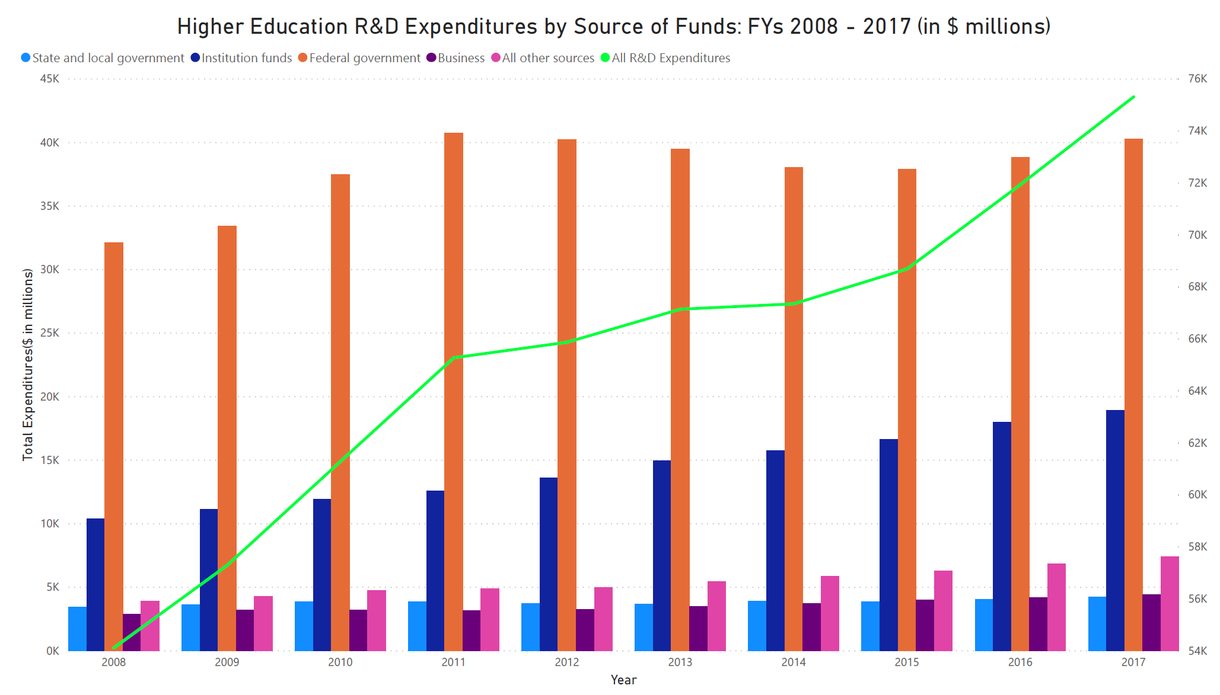

The national average annual growth rate is about 4%, and we see a consistent and slow growth after 2011. The net growth in this decade is 39% from 2008 and $54 billion in 2008 to $75 billion in 2017. Drexel’s average annual growth rate is about 1.6%, and it has a decreased trend from 2013 to 2015.The total Amount of funding has been slowly increasing after 2015. The net growth in this decade is 34% from 2008, $103 million in 2008 to $138 million in 2018. The bar chart below shows 5 major funding sources as federal fund in orange and institution fund in blue. As is generally the case across major research universities, federal funds account for most of the R&D spending in all followed by institution fund. The reliance on federal funding for university R&D is declining and reaches the lowest on record by 2015. This decline is not due to reduced funding, but rather is the result of the expansion of non-federal funding sources.

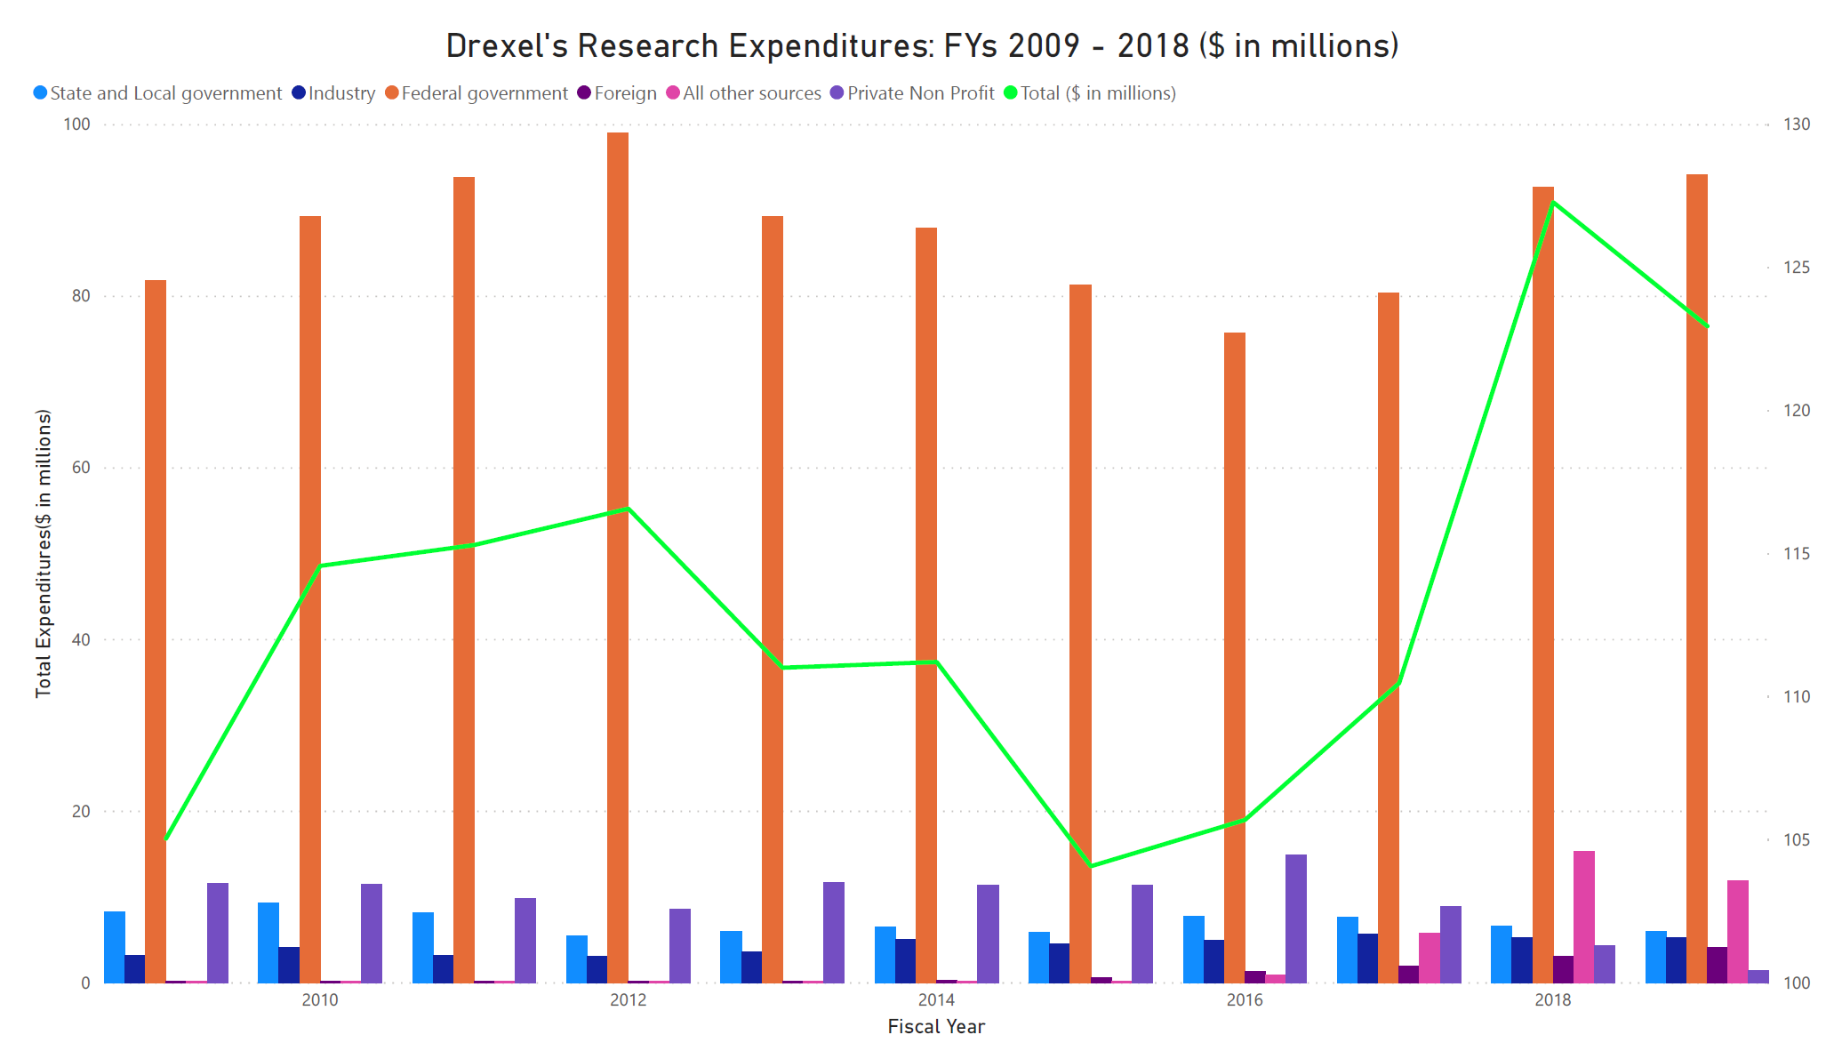

The figure below shows R&D Expenditures by median Amount from 2008 to 2017. Even the total Amount of funding has been increasing, the graph shows a sharp dip in by median dollar Amount in 2011. By 2011, there was a significant increased Amount of schools applied to the funding. As the top largest research universities continued to receive the funding at an increased rate, a large percentage of the schools that are on the bottom of list struggled to split a share of funding in that year. The private research universities over this decade follows much the same pattern national trend as observed among the 644 institutions. In addition, the Pennsylvania institutions showed a steady slowly increase after 2009 keeping at 3 billion in total each year. Pennsylvania private schools has an average growth rate of 5% that exceeded the national average annual growth rate of 4%.

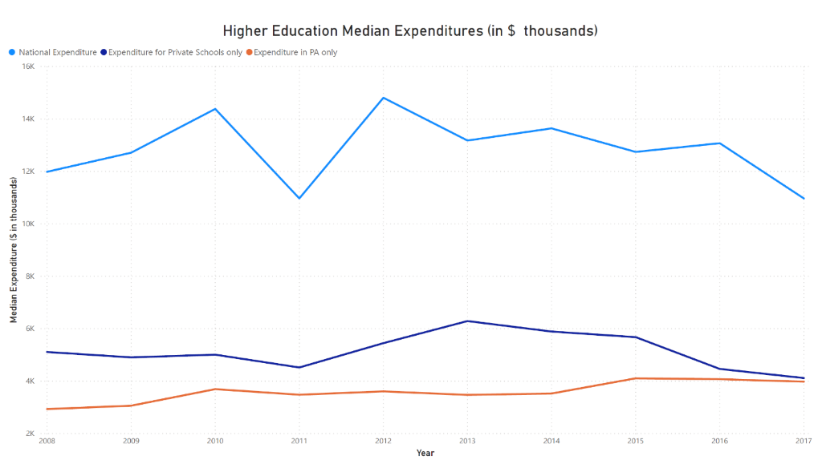

The figure below is **higher education** median **Expenditures** by different subject fields **(in dollar thousands)**. The time frame of data covers from **2008 to 2017**. **General Science** takes up to **80% of the funding** including **Life science** **57%** and **Computer and** information sciences 28%; . Engineering takes 16% of total spending. Within the time frame, life science has 4% annual growth rate; engineering has 5% annual growth rate; computer and information sciences have 5% annual growth rate; non-science and engineering have 8% annual growth. Research at top government-funded universities is heavily concentrated in life sciences and engineering fields. Within these fields, medicine is nearly always the largest recipient of research funds - and, as a consequence, federal research grants.

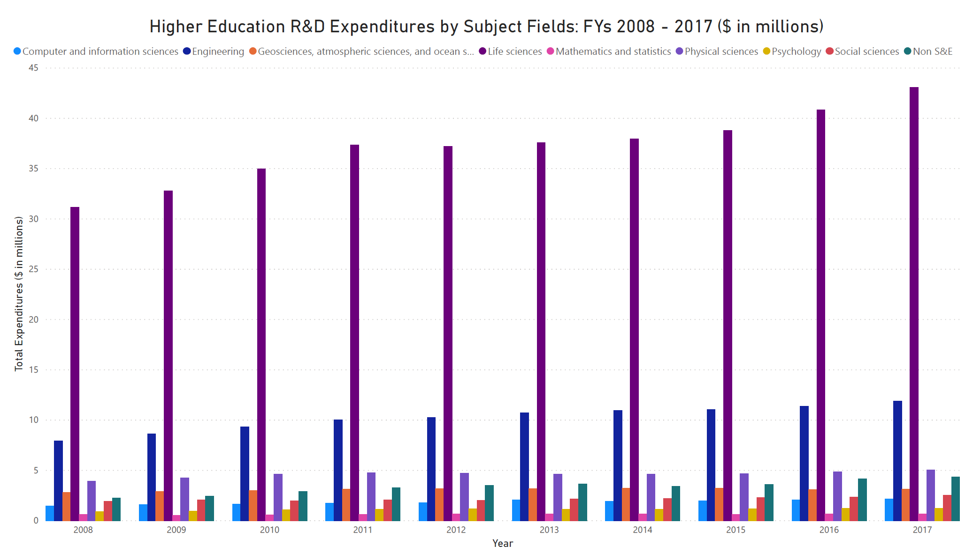

Northeastern University and New York University (NYU) are chosen as the competitors for Drexel University. They both are private schools and also in “R1: Doctoral Universities – Very high research activity” list. The table below shows some information related to research of each university. For the Proposals submitted, Award obligated and Expenditures on research, Drexel has similar data comparing to Northeastern University and owns 45 patents, which Northeastern only owns 25. However, the gap between Drexel and NYU is obvious. NYU has twice as many patents as Drexel. Also, NYU spent $917 million on research in fiscal year 2017, almost 7 times compared to Drexel.

# Data Summary

We have 3 datasets including Proposals dataset with records specific to when Proposals were made from each department of Drexel, Awards dataset which includes details on when the Proposals were approved and then converted to Awards, and Expenditures dataset which captures the details on Expenditures for each Award in the years.

In Proposals dataset, there are 9,792 observations with 26 variables being categorical and 22 as numeric. “Proposals Number” is a primary variable, which helps us to track Proposals that were converted in Awards dataset. Proposals range from calendar year 2010 till date. In Awards dataset, there are 7,392 observations with 33 variables being categorical and 21 as numeric. “Banner” in the Award dataset helps us to track the Expenditures in Expenditures dataset. In Expenditures dataset, there are 123,650 observations with 42 variables being categorical and 6 as numeric. “Fund Code Key” in Expenditures is linked to “Banner” in Awards.

Below are the percentages of missing records in all the datasets, based on analyzing each column cleaning measures will be taken on each dataset.

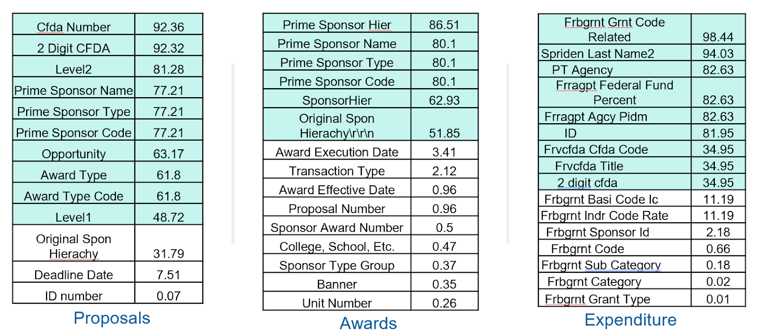

In order to calculate Hit Rate, we decided to join Proposals and Awards by Proposals numbers. We got rid of over 3,000 Proposals within two datasets. After joining two datasets, firstly, we removed 25 duplicated columns with most missing values. Then we removed most of the columns which had over 50% missing values, including “Awards Type Code”, “Cfda Number”, etc., We kept some useful columns including “Primary Sponsor” even though they had over 50% missing values. There are some issues in the process of data cleaning. One of them was the fiscal year of few of Awards were pre-dated before Proposal’s fiscal year, which could cause inconsistency data, so we removed 24 observations. Finally, all variables with most missing values and inconsistent observations were removed and now the cleaned Proposals and Awards has 4,139 observations with 78 variables.

For Expenditures dataset, we dropped variables “Frbgrnt Grnt Code Related”, “2 digit cfda” & “Spriden Last Name2” from the set.“PT Agency”, “ID”, “Frvcfda Title”. We replaced the <NA> values with the “NA” Strings as they can be considered as NA level while analysis instead of dropping it. Similarly, numeric variables like “Frragpt Federal Fund Percent”, “Frragpt Agcy Pidm”, and “Frvcfda Cfda Code” was substituted to 0 instead of <NA>. Finally, all the rows with missing values were removed and now the cleaned Expenditures has 108,430 observations with 43 variables.

**Proposals Summary**

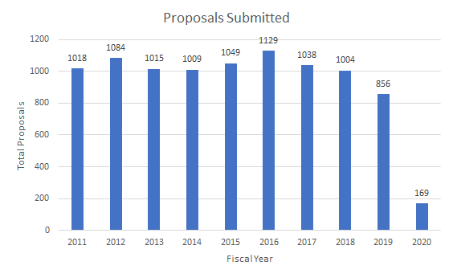

We filter the Proposals with New and Resubmission, then count distinct Proposals numbers each year. Overall the total number of Proposals submitted by colleges over year are decreasing.

**Awards Summary**

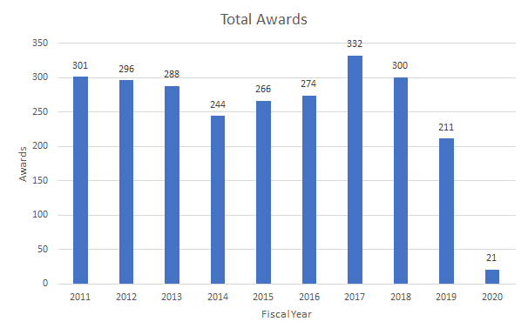

**Proposals Amount Summary**

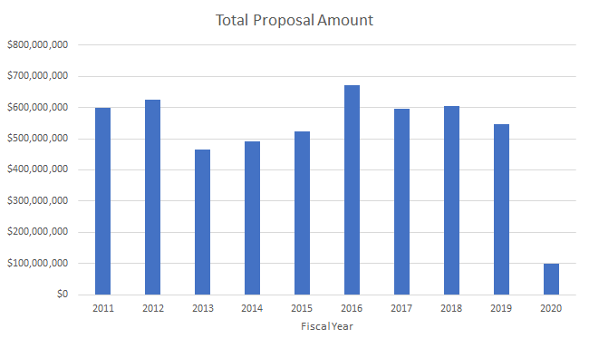

For the Total Proposals Amount, we filtered it by New and Resubmission, then we sum the total Proposals Amount, not the obligated Amount.

**Awards Amount Summary**

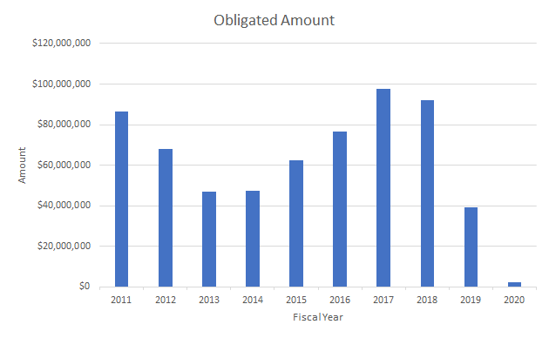

As in for the **Awards** **Amount** Summary, we filtered by **Proposals** type with New and Resubmission. Then sum by the obligated **Amount**s for each fiscal year.

# Data Analysis

Next, let’s move forward and discuss more about Drexel University. Above all, the most important aspect of a university’s research is research Expenditures. According to the U.S. News, when it comes to university rankings, research Expenditures plays a significant role for master’s and PhDs. So, it is reasonable to discuss what is our current position in terms of Drexel research Expenditures.

According to the dataset and visualization below, in the year 2018, Drexel University has a research Expenditures Amount of 127 million dollars. Furthermore, there are 580 agencies so far who support Drexel research program 2018. And, just a fun fact, Lebow College of Business has an Amount of 377 thousand dollars in research Expenditures. However, Lebow College of Business is not the top colleges which have the most research Expenditures spent over the years since, as a business school, research is not one of our main college functions. Thus, it is critical that we focus on colleges that have a large Amount of research Expenditures over the 10-year period.

According to the data, in the years between 2009 and 2019, the top 3 colleges that have the majority of the research Expenditures are College of Medicine, College of Engineering and College of Art and Science with a 38%, 19% and 9% of total research Expenditures respectively. Thus, let’s take a close look at one of the major colleges, College of Engineering, as an example. For year of 2018, College of Engineering has an Amount of total research Expenditures of 20 million dollars. The peak of total Expenditures is in year 2012 and 2013 with 27.5 million dollars and 27.3 million dollars respectively. However, in terms of number of supported agencies, in year of 2018, there are 106 agencies year to date that support College of Engineering research and as for now, there are 111 agencies in 2019 year to date. As we look at the trends of the number of research Expenditures as well as the number of supported agencies, it tends to be the same over the year if there are no significant changes in regulations or policies, which can be easy for us when we do forecast analysis. Overall, the total number of supported agencies is increasing over the years and the total number of research Expenditures tends to be constant over years disregarding there is a large project came in in 2012 and 2013.

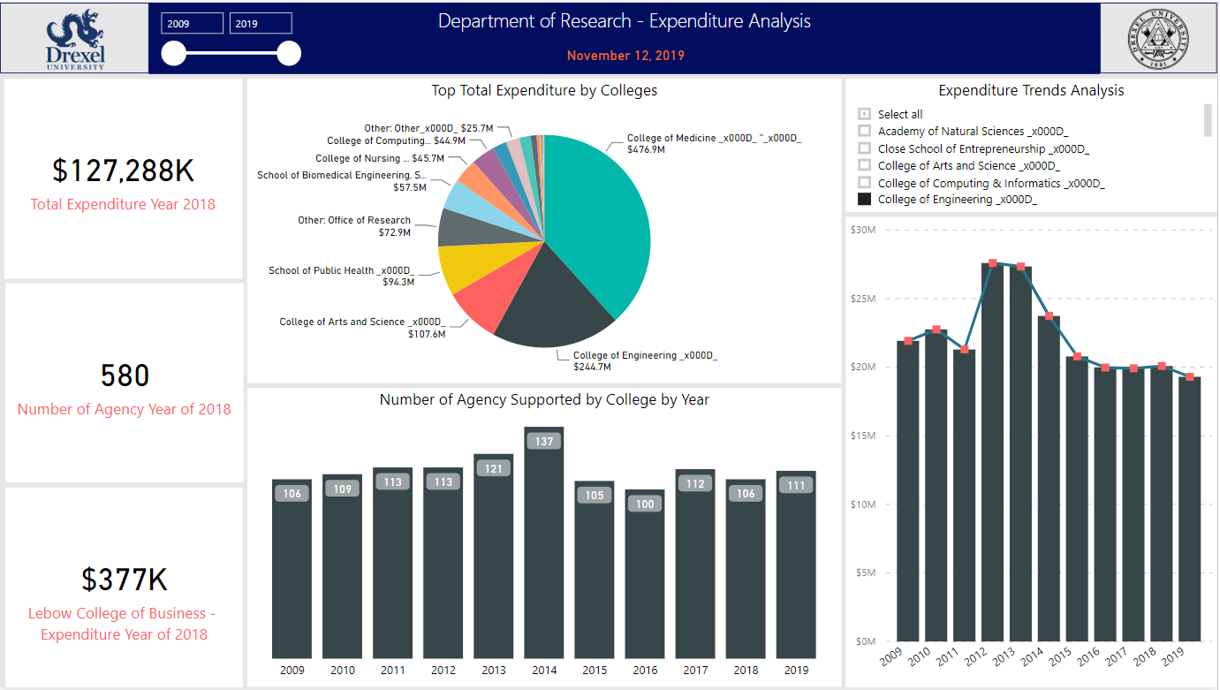

However, Lebow College of Business is not the top colleges which have the most research Expenditures spent over years since, as a business school, research is not one of our main college functions. Thus, it is critical that we focus on colleges that have a large Amount of research Expenditures over the 10-year period. According to the data and visualization shown above, in years between 2009 and 2019, the top 3 colleges that have the majority of the research Expenditures are, College of Medicine, College of Engineering and College of Art and Science with a 38%, 19% and 9% of total research Expenditures respectively. Thus, let’s take a close look at one of the major colleges, College of Engineering, as an example. For year of 2018, College of Engineering has an Amount of total research Expenditures of 20 million dollars. The peak of total Expenditures is in year 2012 and 2013 with 27.5 million dollars and 27.3 million dollars respectively. However, in terms of number of supported agencies, in year of 2018, there are 106 agencies year to date that support College of Engineering researches and as for now, there are 111 agencies in 2019 year to date. As we look at the trends of the number of research Expenditures as well as the number of supported agencies, it tends to be same over the year if there are no significant changes in regulations or policies, which can be easy for us when we do forecast analysis. Overall, the total number of supported agencies is increasing over years and the total number of research Expenditures tends to be constant over years disregarding there is a large project came in in year of 2012 and 2013.

After discussing research Expenditures, let’s talk about Proposals and Awards. According to the data and visualization shown below, in year 2018, the total Proposals Amount of the year is 623 million dollars with a total number of direct cost Amount of 466 million dollars. Besides, in year of 2018, 931 Proposals had been submitted. Among all the Proposals submitted, College of Medicine, College of Engineering and College of Art and Science take the most percentage, with 28%, 23%, and 12% respectively. However, when we look at the number of Proposals submitted by colleges over year, the number is actual decreasing. For instance, from year 2012 to 2019, the number of Proposals submitted for College of engineering dropped from 313 to 103 respectively. As a result, the number of Proposals Amounts is also decreasing from 146 million dollars in 2012 to 45 million in year 2019 year to date. This is a significant aspect for our future analysis, and we are going to test more in this area and find out the reason why the numbers are dropping. The next step for us is to learn more about our Awards. In year of 2018, the total obligated Amount is about 135 million dollars with a number of Sponsors of 277. Among these Sponsors, only 13 numbers Sponsored a project or several projects over 1 million dollars. From year 2009 to year 2019, majority of our researches are Sponsored by Federal agencies, about 65 percent. One of the examples for Federal Sponsorship is College of Engineering, with 79% Federal agencies Sponsored and 971 Awards.  However, not all colleges are Sponsored by Federal. For instance, from year 2009 to year 2019, College of Media Arts and Design have a large number of Sponsorships from private agencies, with 60% private agencies. Why is it like this? What are the reasons that some colleges have Sponsorships from Federal and others from other types of agencies? Is this situation going to impact our Proposals, Awards and research Expenditures? We are going to exam those area in detail further.

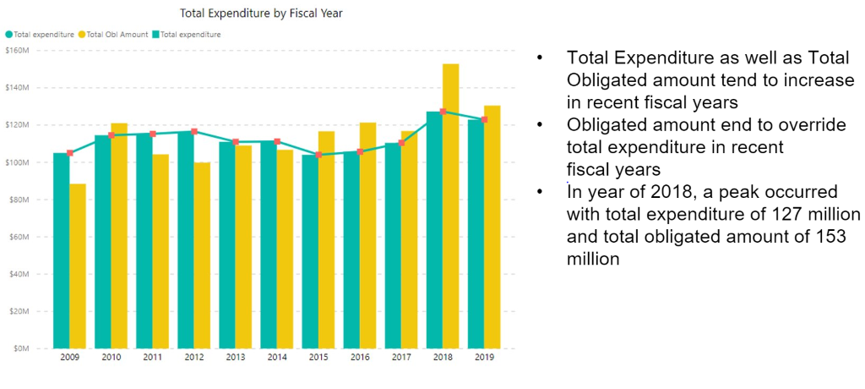

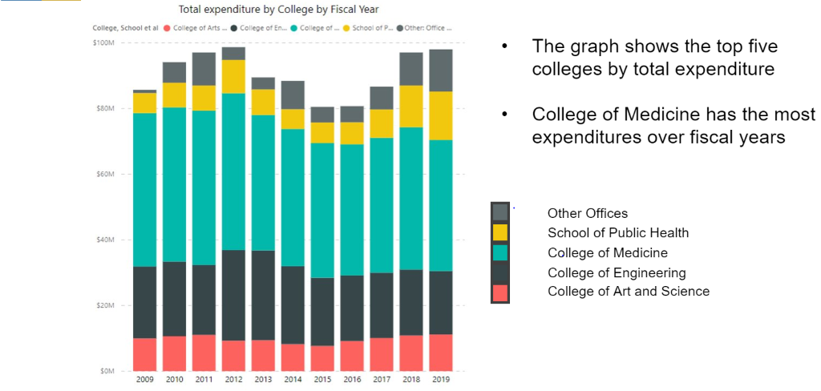

**College of Engineering**

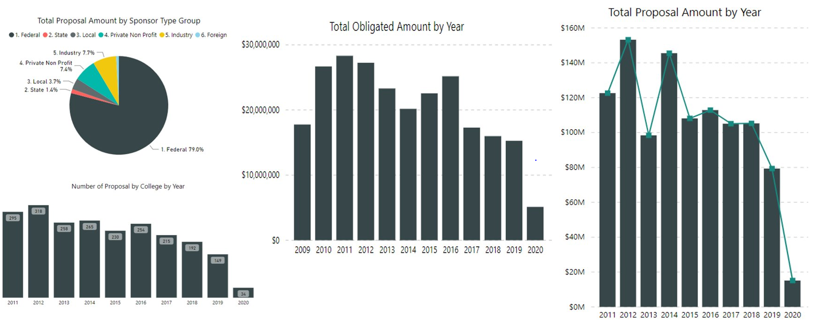

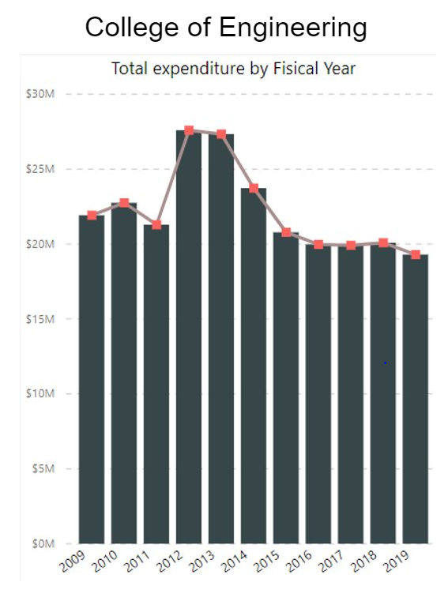

**College of Medicine**

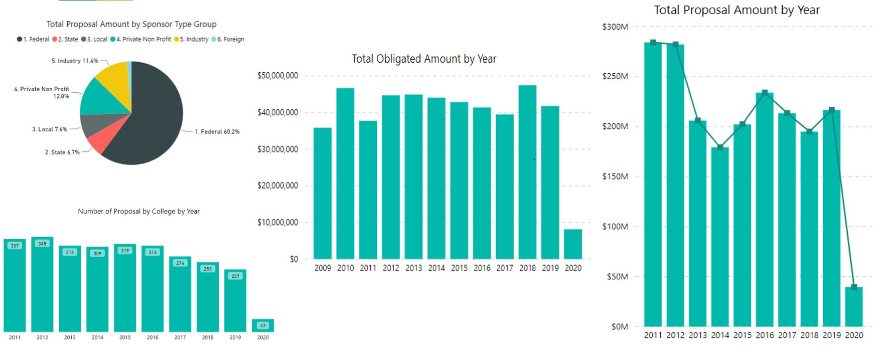

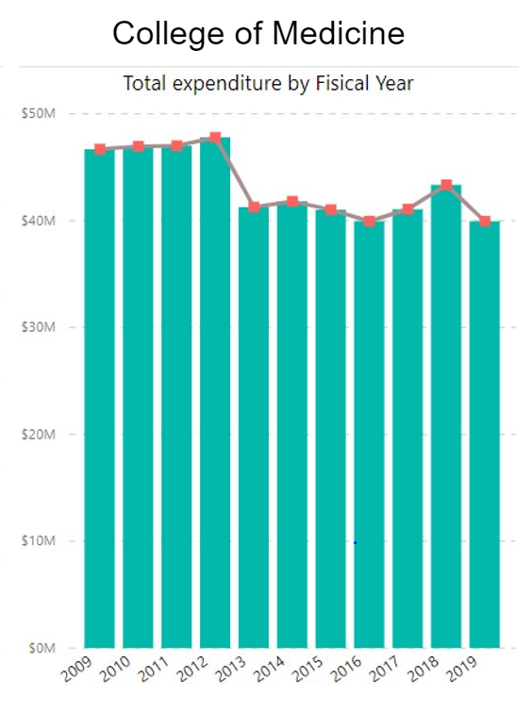

**College of Art and Science**

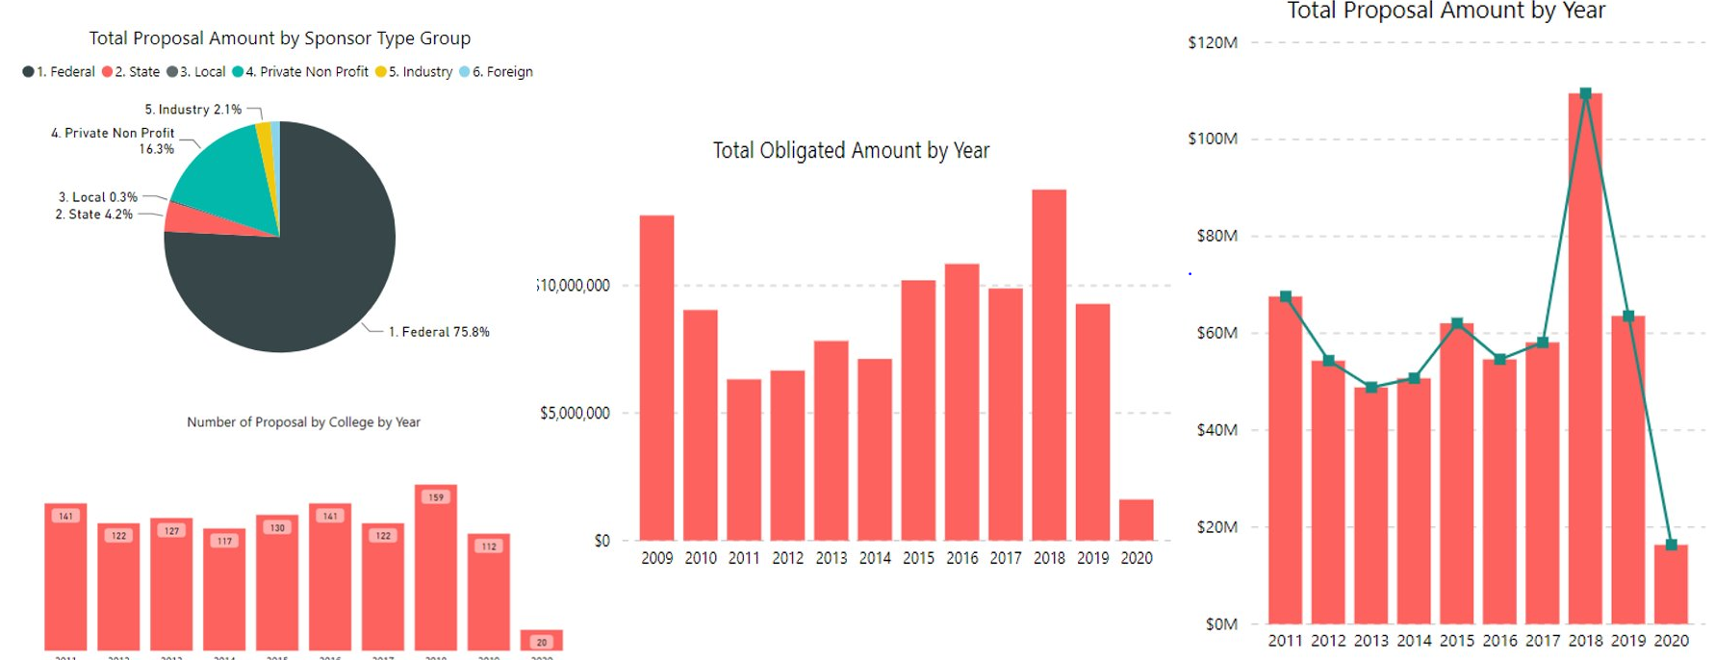

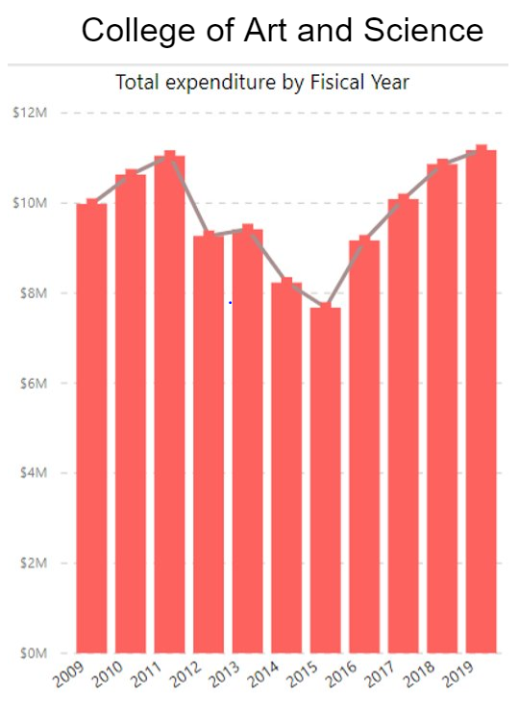

Since there is a clear distinction between Sponsor types, we decided to do a further detail analysis and dig deeper. Overall, in fiscal year of 2019, there are 300 Sponsors among all Sponsor types. The first aspect we tested on is the number of Sponsors by Sponsor types. From year 2009 to year 2019, the top three categories are private (40% of total with total of 604 Sponsors), industry (27% of total with total of 402 Sponsors and federal (22% of total with total of 323 Sponsors). The second aspect we tested on is the number of Awards by Sponsor type. From year 2009 to year 2019, the top three categories are federal (48% of total with a total of 3565 Awards issued), private (28% of total with a total of 2040 Awards issued), industry (12% of total with a total of 913 Awards issued).

We can see that the number of Sponsors in federal type is not a lot, but this kind of Sponsors issues the largest number of Awards over years. Thus, the third aspect we tested on is the number of Proposals by Sponsor types. From year 2009 to year 2019, over 68% of Proposals were submitted to federal agencies with a total number of 6684 Proposals submitted. Private agencies are 20% and industry agencies are 5.5% of total. And the fourth aspect we tested on is total Proposals Amount 1.3 billion over the ten-year period (about 90%). So, results showed that the majority of colleges wanted to submit Proposals to federal agencies since they tend to approve more and the number of Awards which federal agencies provided are higher than others. However, the competition in this kind of agencies will be really high since only 50% of the Proposals will be approved.

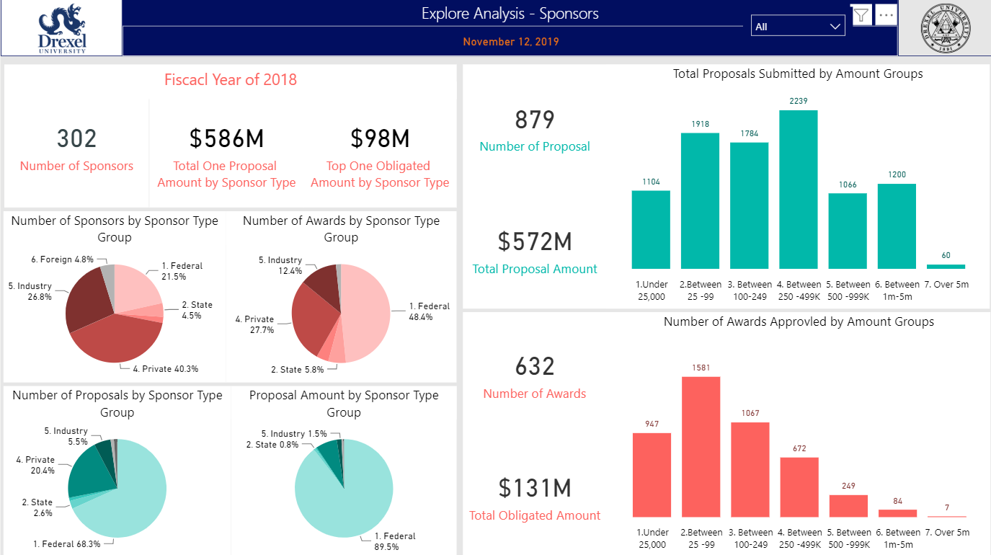

Moreover, let’s take a deeper look into each Sponsor types in terms of Amount group. For instance, in federal Sponsors, most Proposals submitted are in between 250K to 499K Amount range with 1948 Proposals submitted over the ten-year period. However, only 524 of them got approved and turned into Awards. The most Proposals which got approved are actual in 25K to 99K with a number of 832 Proposals submitted and 669 got approved. Thus, we learned that federal agencies preferred some Amount Awards and issued a lot of them for different projects. However, in terms of private agencies, the situation is pretty much the same except that most Proposals are in the 25K to 99K range and they got approved the most. And if we take a look at the trend, the large the Amount goes, the less Awards approved.

**Federal**

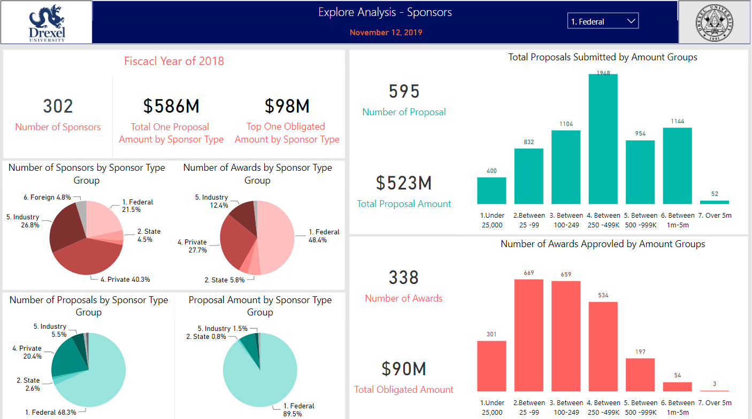

**Private**

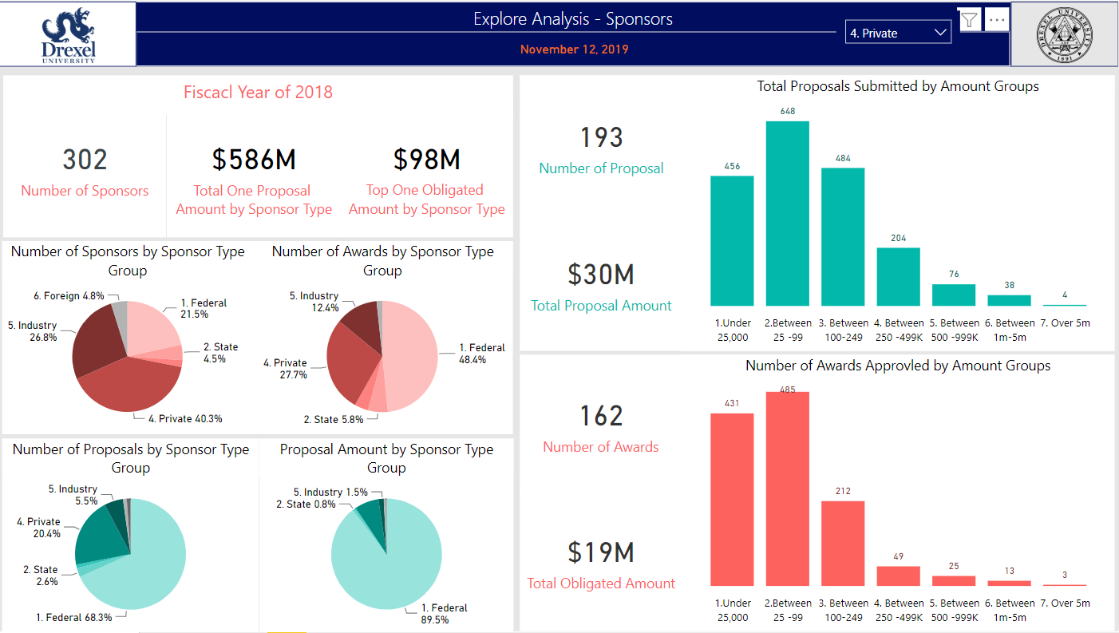

**Industry**

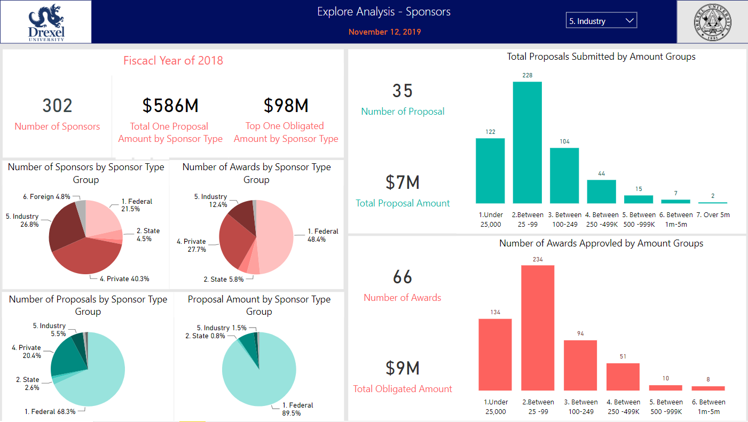

# Clustering based on AAPCR Analysis for all the Colleges

The table below is the Clustering for Awards by colleges. We took compound growth factor into calculation to find the average annual percentage change rate (AAPCR), which can tell us how fluctuant or stable the Awards Amount that each college has been receiving over the past 12 years. We sorted by the absolute value and comparing to the % of obligated Amount, which is Drexel’s total Awards Amount. We found out a similar trend between the AAPCR and % of obligated Amount within each Cluster. The green Cluster has a stable and consistent Awards growth rate and counts as the second-largest % of total Awards Amount (26.8%). This group of college give us the most information to analyze. The blue Cluster has the Moderate fluctuation in Awards receiving Amount in certain year, but it is still worth to group them to study more given the noticeable Awards Amount. We singled out College of Medicine in red Cluster. It has a moderate fluctuation in Awards receiving Amount and counts as the largest % of total Awards Amount. The grey Cluster has the most fluctuated Awards receiving pattern and counts as a large % of total Awards Amount. The white Cluster has either discontinued or missing year with inconsistent Awards Amount pattern and counts as the least % of total Awards Amount. For forecasting model, we have decided to omit the yellow Cluster, which has a stable Awards growth rate but contributes to a very subtle % of total Amount due to the lack of record.

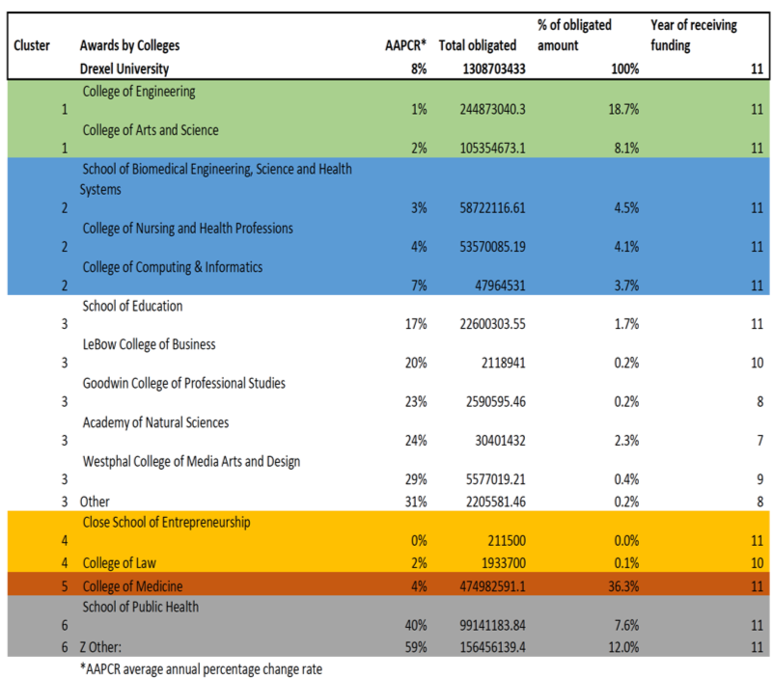

Next, we applied the same Cluster to Expenditures by colleges. There is a similarity for each Cluster between their Expenditures and Awards patterns. The green Cluster has a consistent and stable pattern for Expenditures growth rate as well as for the Awards growth rate and both count as the second largest % of total Amount respectively. The blue Cluster has a moderate fluctuation in annual spending and counts significant % of total Expenditures Amount. The College of Nursing is an exception in this Cluster, which has the most consistent Expenditures Amount, but its Award Amounts have been fluctuant quite bit over the years. The red Cluster is College of Medicine, which has the largest % of Expenditures Amount and both Expenditures and Awards Amount have some noticeable changed over the years, that could be the Expenditures Amount has been justified based on the Awards receiving Amount. The grey Cluster includes all other administration departments together. It has the most fluctuated Expenditures pattern and counts as large % of total Expenditures Amount. School of Public Health and the Office of Research have significant % of Expenditures Amount that make the prediction harder unless we break them down into more granular Clusters. The white Cluster follows the same pattern as for Awards Amount that it has wither a discontinued or missing year with inconsistent Expenditures pattern and that it counts the least % of total Expenditures Amount. The yellow group will be omitted due to lack of data.

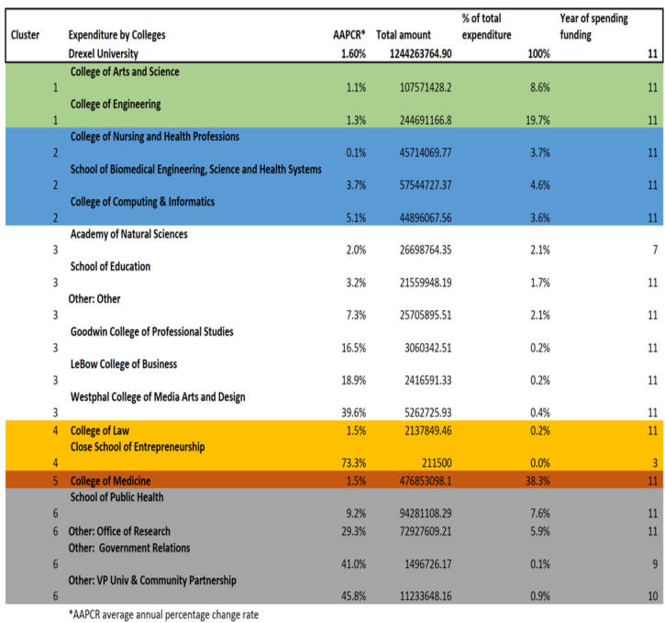

# Hit Rate Calculation

As Hit Rate served as an indicator of Drexel’s research ideas attracts funding; thus, in our Hit Rate calculation, we chosen Proposals type as "New", "Resubmission", and "Revision", and Award type as “New”. We found out it is a norm that there could have a higher chance to be converted if Proposals were resubmitted. For resubmission and revision Proposals, they would be assigned to new Proposals numbers, so we included them to the Hit Rate calculation. In order to keep time period more consistent, we chose fiscal year on both datasets. The formula used to calculate the Hit Rate is numbers of new Proposals converted to Awards each year divided by total new Proposals submitted each year. If same Proposals received multiple Awards in different year, we only kept the oldest date and counted as one conversion. For example, Proposals number 10010901 was received different Awards in 2010,2012,2013, and 2014. We only saved its record as one conversion in 2010 to avoid multiple conversion counts.

Another important thing to consider was lag year – difference years between a Proposals submitted and a Proposals received an Award. In most cases, after faculties submitted Proposals, they need to at least wait for six to eight months. For some cases, waiting time will go up to four years. In order to calculate lag year for each Proposals received an Award, we created the table *(Lag Year Table)* below as an example. For new Proposals, we have columns the year when it submitted and when it received an Award. Lag year was differences between Awards Year and Proposals Year. If lag year was 0 as Proposals number 10102071, we recorded one conversion in 2011; if lag year was 4 as Proposals number 10102113, we recorded one conversion in Proposals Year 2011 instead of 2015 and so on. Finally, we added up Award count by years along with lag years. Showing on Hit Rate Table, the way we calculated Award count for 2011 on the right-side table was, to sum up Award count of Proposals Year 2011 on the left-side table even though those Proposals were received Award in 2011,2012,2013, 2014, and 2015. Finally, we used Award count in 2011 divided by Proposals count in 2011 to calculate Hit Rate in 2011.

|  |  |  |  |
| --- | --- | --- | --- |
| **Proposals Number** | **Awards Year** | **Lag Year** | **Proposals Year** |
| **10102071** | **2011** | **0** | **2011** |
| **10102113** | **2015** | **4** | **2011** |
| **11012385** | **2013** | **2** | **2011** |
| **11012388** | **2012** | **1** | **2011** |

**Lag Year Table**

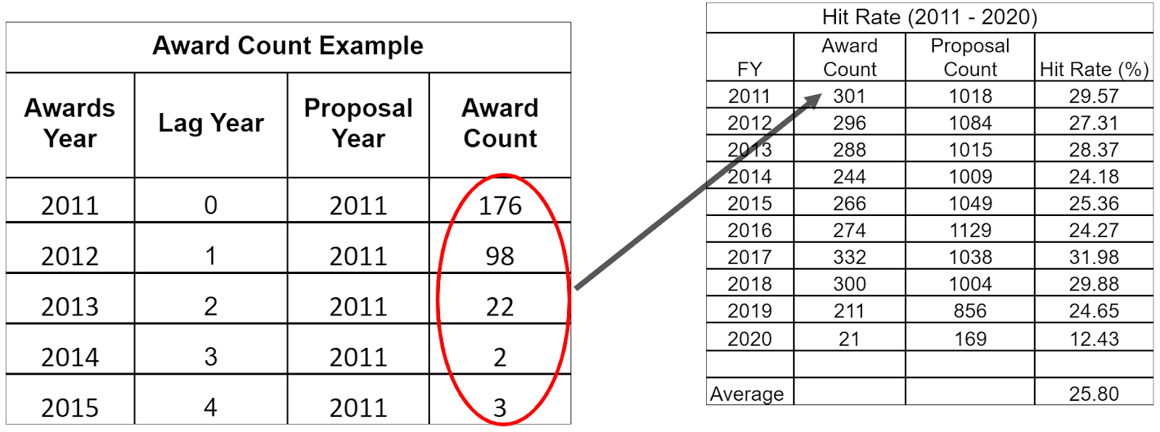 **Hit Rate Table**

Below (Annual Hit Rate Plot)  shows Hit Rate from FY 2011 to 2020. Due to incomplete information in FY 2020, the Hit Rate looks lower. The average of annual Hit Rate is 25.80% and FY 2017 has the highest Hit Rate, which is over 30%. 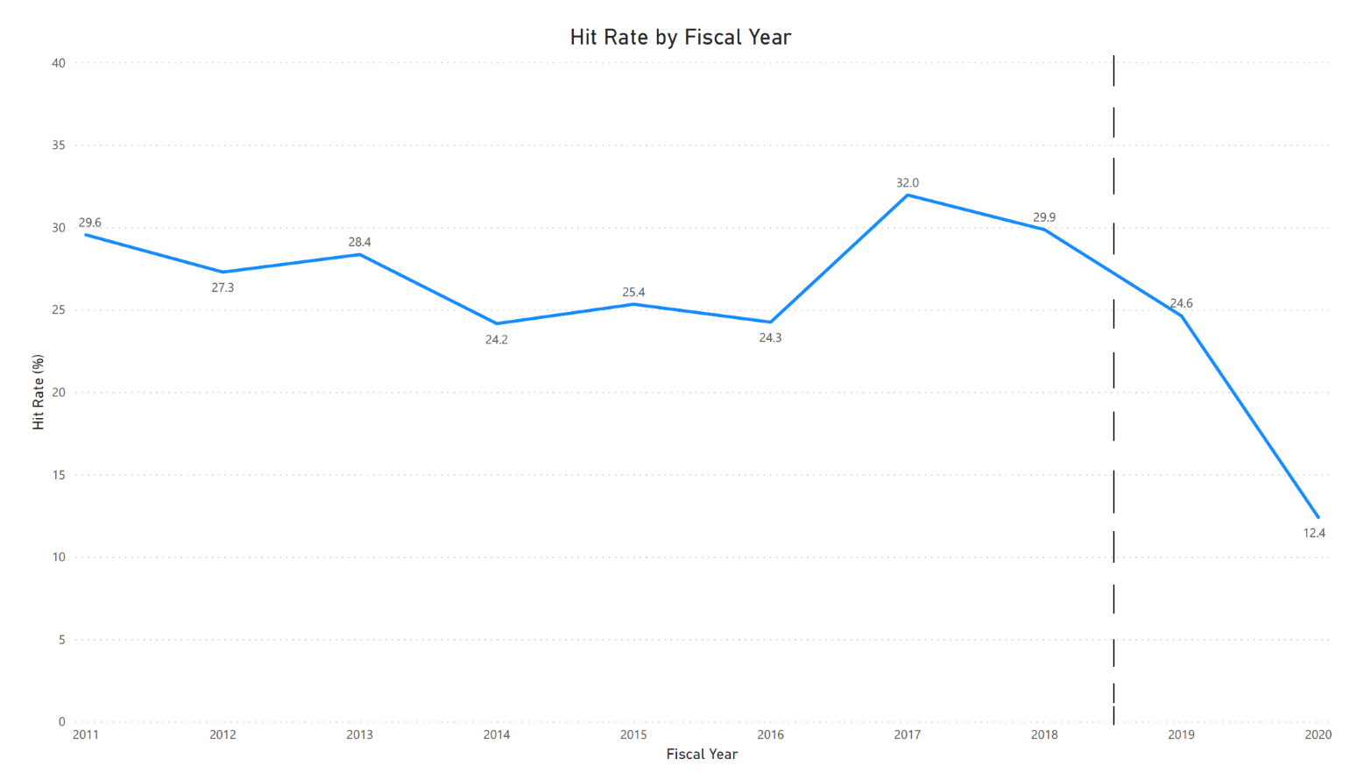

**Annual Hit Rate Plot**

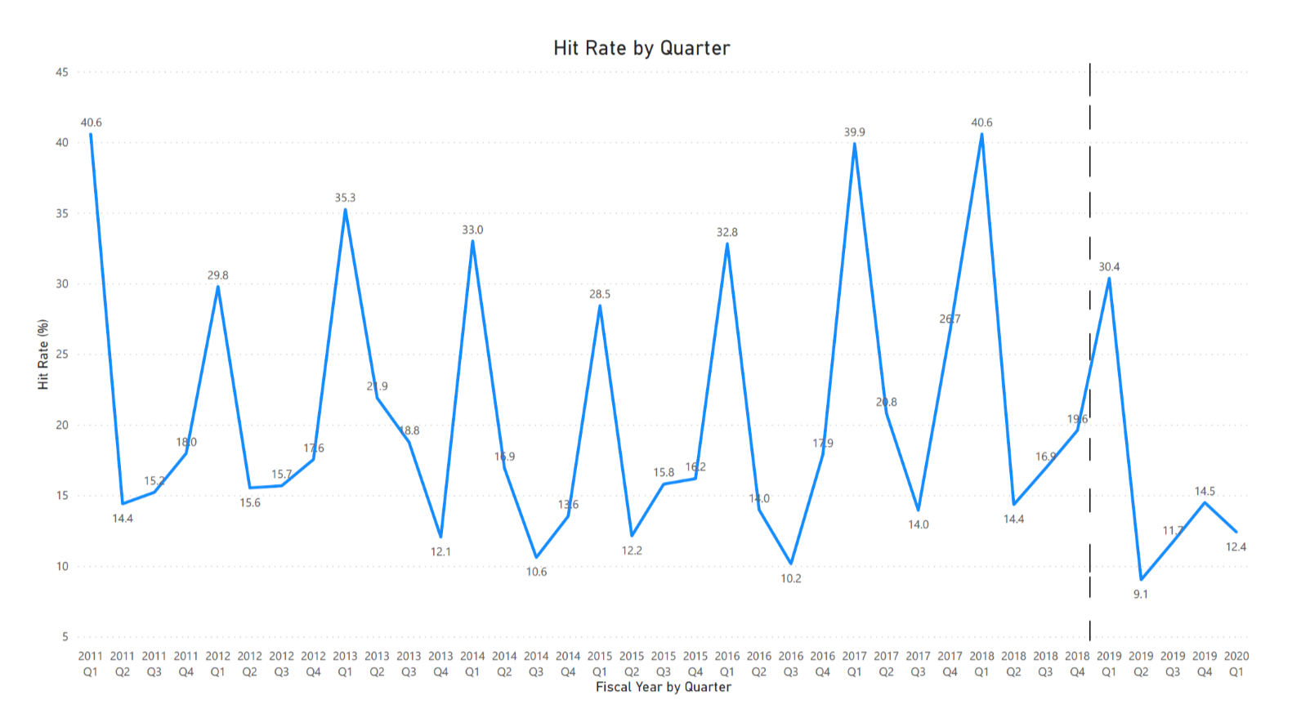

**Quarterly Hit Rate Plot**

We also plotted Hit Rate by quarterly below to see the trend. We found out quarter 1 has the highest Hit Rate and quarter 3 has the lowest Hit Rate over the years. Normally, most of federal funding could announce results on quarter 1. That’s why quarter 1 would have the highest Hit Rate.

**Hit Rate by College (FYs 2011 – 2018)**

In addition, we applied college’s Cluster - 1,2,3,5, and 6 on Hit Rate. Cluster 6 has the highest average Hit Rate (92.67%) due to the most fluctuated Awards receiving pattern. For example, there are a lot of Awards receiving under Office of Research, but Proposals were submitted by other departments or closure colleges. Cluster 5 has moderate fluctuation in Hit Rate, which average Hit Rate is 42.97%. Since Cluster 3 is grouped by outlier colleges (Lebow and Westphal) due to the expansion of the department within the colleges and small but stable Award Amount, the trend of Cluster 3 has the most fluctuation. Cluster 1 and Cluster 2 has the most stable Hit Rate, which average Hit Rate is 34.42% and 38.02%, respectively.

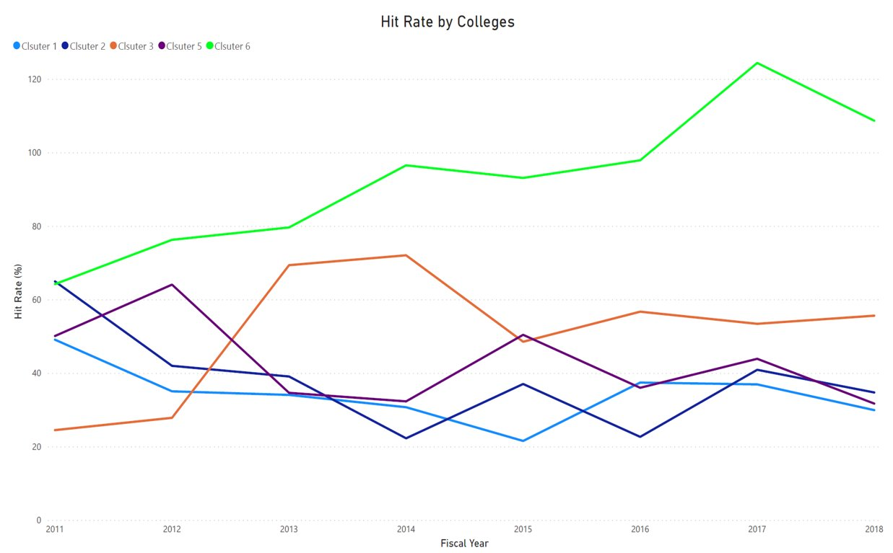

**Hit Rate by College**

**Hit Rate by Amount Group (FYs 2011 – 2018)**

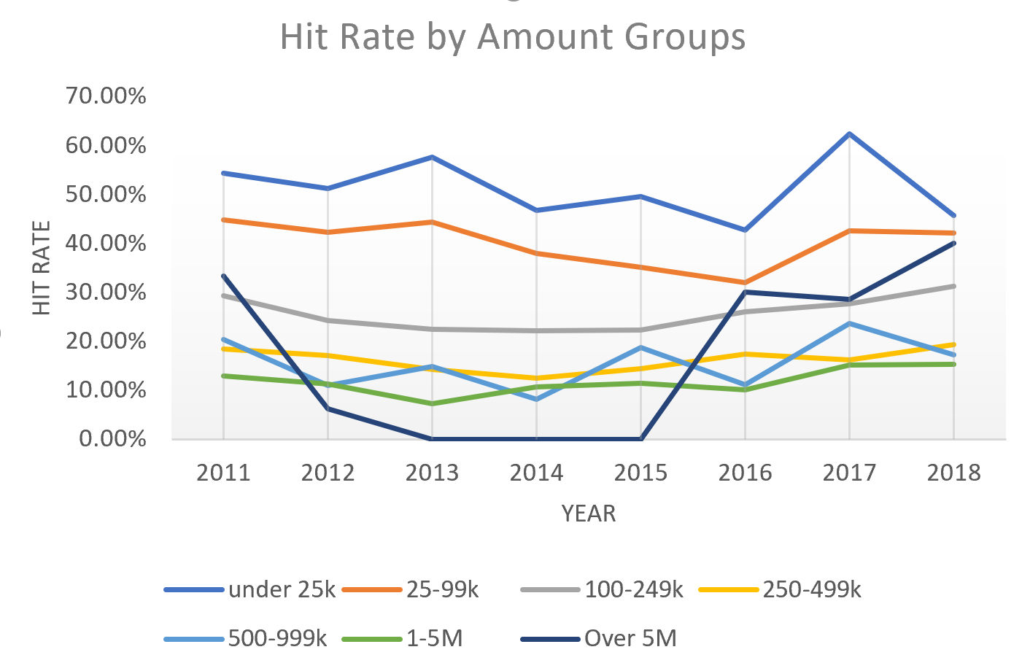

Average Hit Rate is 49.63% which is the highest of all the Amount group for  ‘under 25k’.As the Amount group increases the Hit Rate decreases in all the Amount group except ‘Over 5M’ group. The average Hit rate observed is 23.82% which has been increasing from 2015.

**Hit Rate by Sponsor Type (FYs 2011 – 2018)**

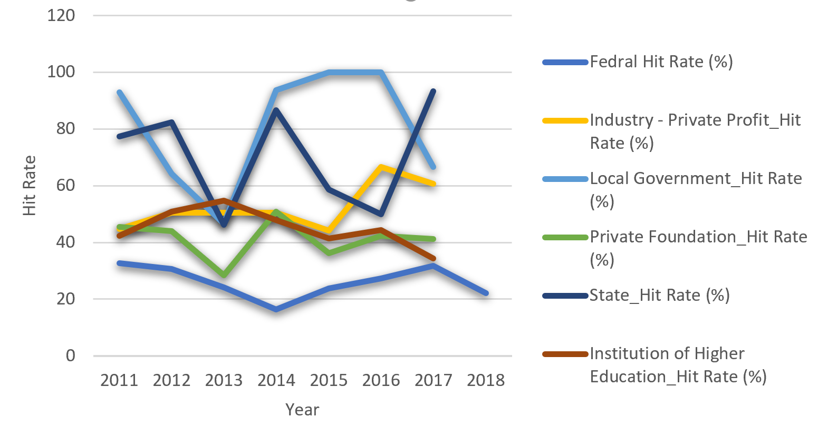

Federal has the largest proportion of the Sponsor type in Proposals and Awards, the average Hit Rate is 26% and has been decreasing in 2018. For Local Government & State, average Hit Rate is 83% & 73% which is higher than all other Sponsor type. Hit Rate for Private Foundation has an upward trend, whereas Hit Rate for  Institution of Higher Education is decreasing over the years.

# Methodology

### Forecast Models

Our modeling methodology took multiple iterations in order to discover the best modeling technique for our data. Once we had developed the Clusters, we had multiple datasets with different patterns. Our first idea was to perform autoregressive integrated moving average (ARIMA) on Proposals since Proposals were the cleanest of the data provided and work from there. We initially forecasted Proposals, used the Hit Rate to estimate Awards, and then forecast Award $ after learning of the relationship between Awards and Award $ via linear regression. We quickly discovered issues with this approach though, as making predictions based off different predictions does not yield high accuracy. So, we then decided to simplify our process, and look at time series models only for Award $ and Expenditures. Since each Cluster behaved differently, we had to run tests on each Cluster separately. This section will walk through the process with Cluster 1.

First, we must examine the quarterly Award $ data within Cluster 1. We can immediately see come patterns that indicate it is possible to create a purely time series forecast.

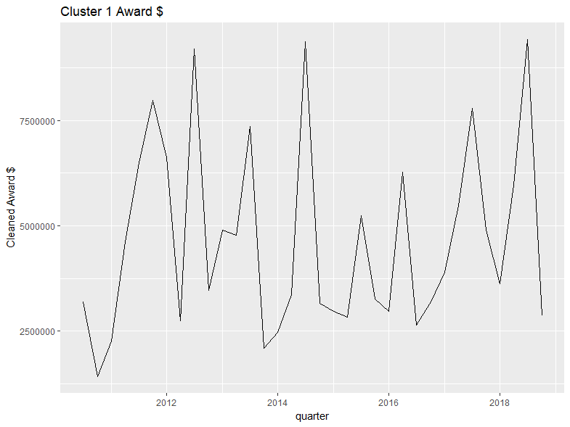

Our first step to transform the data will be to create a bi-yearly moving average. After doing so, we can see that the data is able to be smoothed out, a desirable trait for time series forecasting. Using the bi-yearly moving average allows us to work around some extreme spikes and valleys in the data, making it much easier to make predictions.

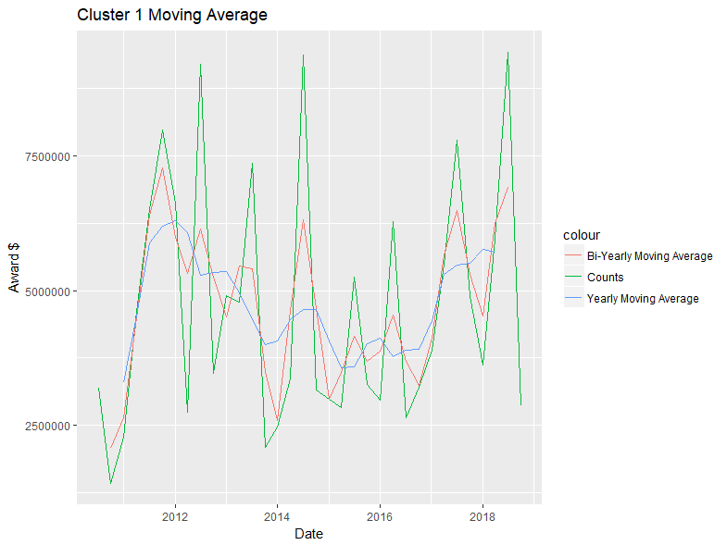

After visualizing and transforming the data, we then get into more technical tests that **ARIMA** requires to create a robust and accurate model. We firstly tease out the seasonality of the data. After getting our de-seasonal data, we need to test for stationarity, as **ARIMA** requires our data to be stationary. We use the Augmented Dickey-Fuller test to determine stationarity.

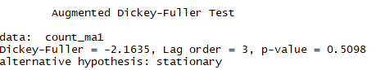

As we can see here, our data is not stationary, meaning we will need to take the difference of the data to pass it through a time series model.

Next, we need to examine the **ACF** and **PACF** lags in the data. After doing so, we are able to account for the lags in our data as well. Looking at the **PACF** graph, we can easily see a significant lag at period (quarter) **2**, meaning we can take this into account for our final **ARIMA** model for **Cluster 1.**

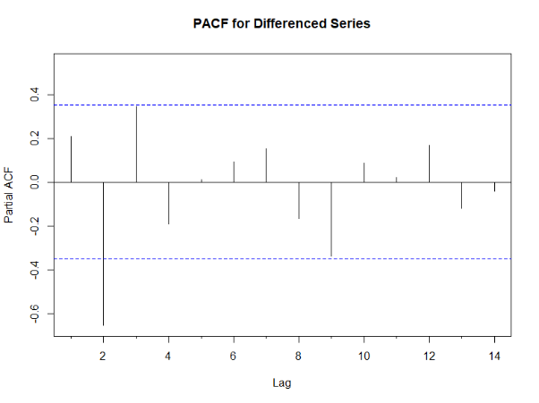

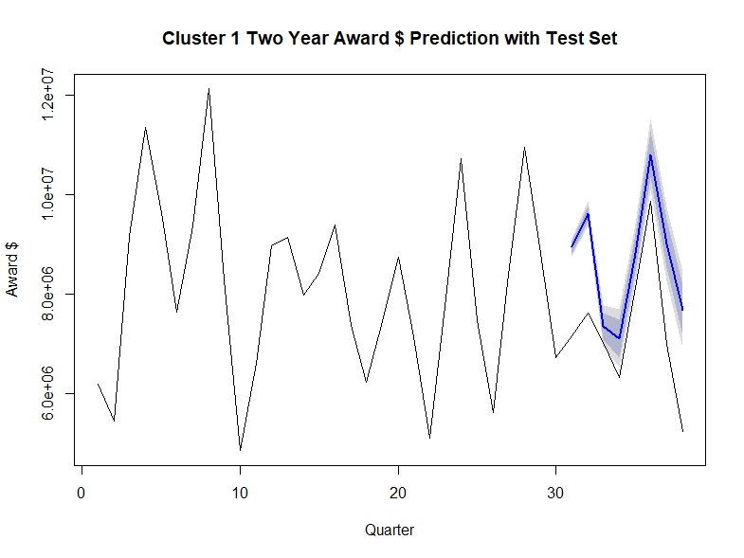

* **O**ur next step is to make the model. We can start with an auto-fit, that minimizes the AIC. That being said, the auto model does not necessarily have the best parameters for our data, as there are a lot of finer details that need to be considered in the model. After much testing and validating, we come across a seemingly good model with **ARIMA** (**17**,**0**,**9**). We create this model with a train/testing dataset (**2** years of data is the test set) and get the following results. The model looks pretty good when testing with our test dataset.

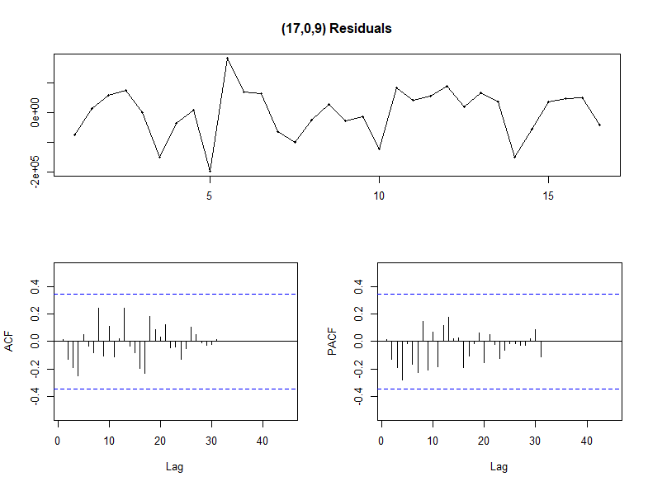

Our next step is to check the residuals of our model, to make sure the residuals don’t break any assumptions when creating our model. The residuals look pretty good, as there are no defined patterns and they look relatively normally distributed according to the line graph. Similarly, our model does not have any significant **ACF** or **PACF** lags, meaning that the **ARIMA** model successfully picked up all the lags and that our data is stationary.

Now that we have tested the model, and looked at the residuals, we can finally make some predictions. We look to forecast 5 years out, and since our data is in bi-yearly moving average form, our predictions will come out bi-yearly. The model provides a pretty good-looking forecast, with 80 and 95% confidence intervals for our data. The model clearly expects the Award $ to drop back down from its recent peak. When looking at the confidence intervals, our model seems to have a good pattern, so we are pleased with the output of the forecast. This pattern is replicated across all Clusters for both Award $ and Expenditures separately.

In order to forecast Expenditures, we needed to make some assumptions about our data, since it only came in yearly form. We assumed that the % of Expenditures in each quarter replicates that of the Award $. We were able to take the average % of yearly Award $ for each quarter and apply that to Expenditures.

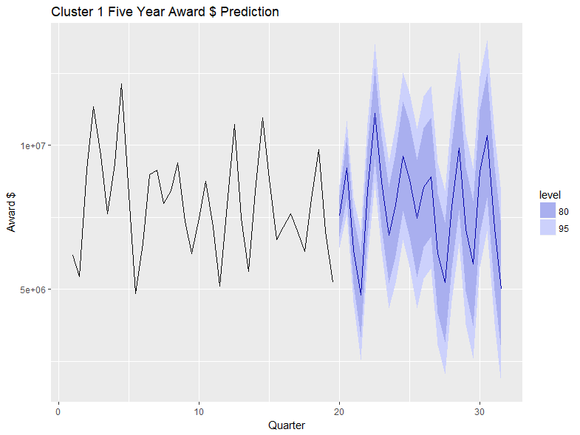

# Cluster Forecast Results

* **Cluster1:**

For **Cluster 1’s Award forecast**, the **ARIMA(17,0,9)** model seems to give a directionally correct forecast and the **lowest MPE**. Around **6.67%** **MPE** implies the model is about **93.3% accurate** in predicting the next observations.



**Cluster 1’s Expenditures forecast** uses **ARIMA(19,1,5)** and has an **MPE of -.7%**, indicating very **high accuracy of 99.%**. This data is very good for forecasting, hence the **high accuracy**.

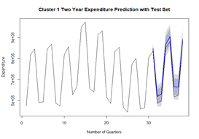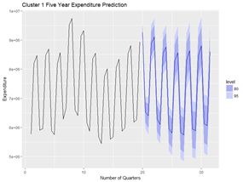

* **Cluster 2:**

**Cluster 2’s Award forecast** used **ARIMA(19,1,5**), and had an **MPE of -0.7%**.

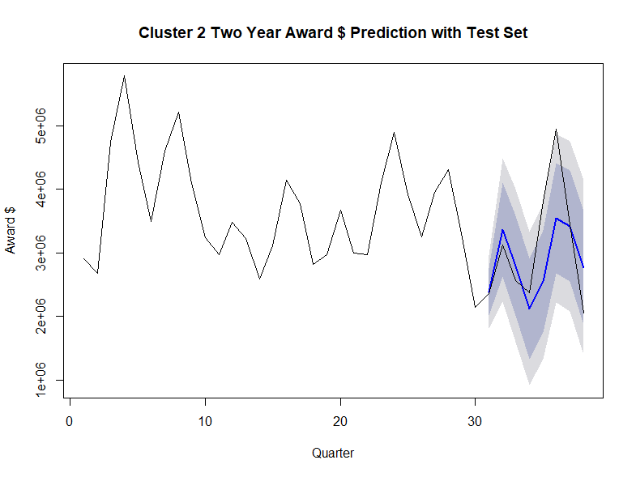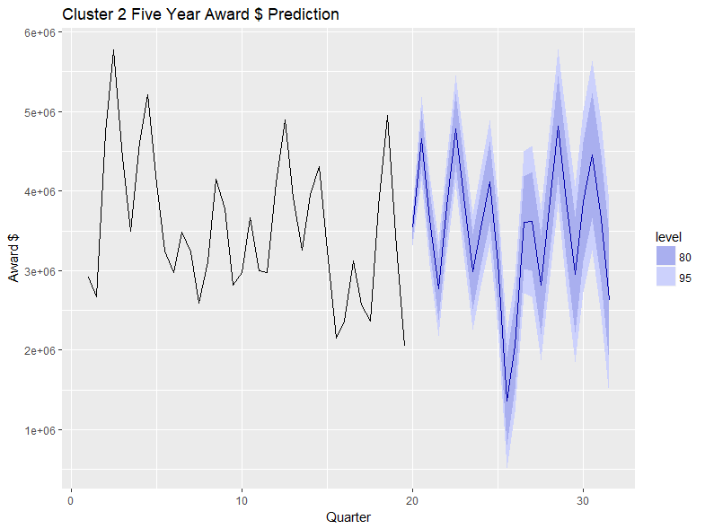

**Cluster 2’s Expenditures forecast** used **ARIMA(3,1,5)** and had a **MPE of 19.5%**.

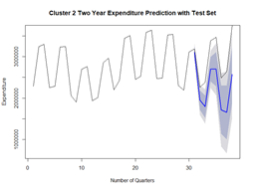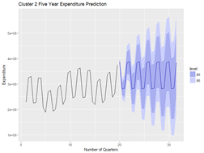

* **Cluster 3:**

**Cluster 3’s Award forecast** used **ARIMA((19,1,5)**, this forecast had a **difficult pattern** to follow, but the model does a good job of using a **large moving average** to help atone for the disparity in data.

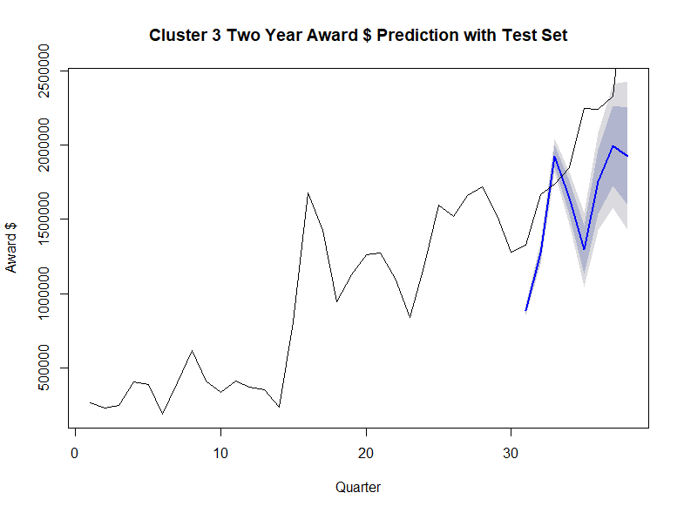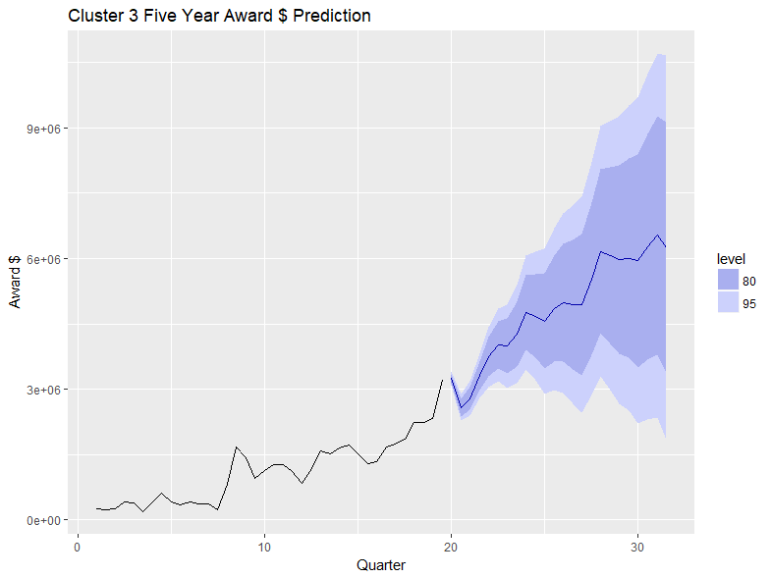

**The Cluster 3 Expenditures forecast** used **ARIMA(15,1,15)**. This data is very difficult to model, as there is **random valleys** and a l**arge spike towards the end of the dataset**. This leads to a **MPE of 50%**.

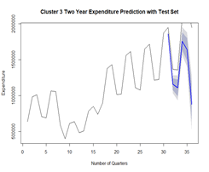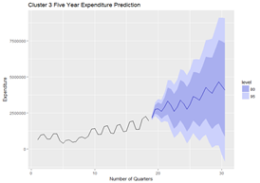

* **Cluster 5:**

**Cluster 5 Awards forecast** uses **ARIMA(19,0,21)** and yields an **MPE of -36.6%** This dataset was also difficult to model, as indicated by how the forecast **begins to smooth out**.

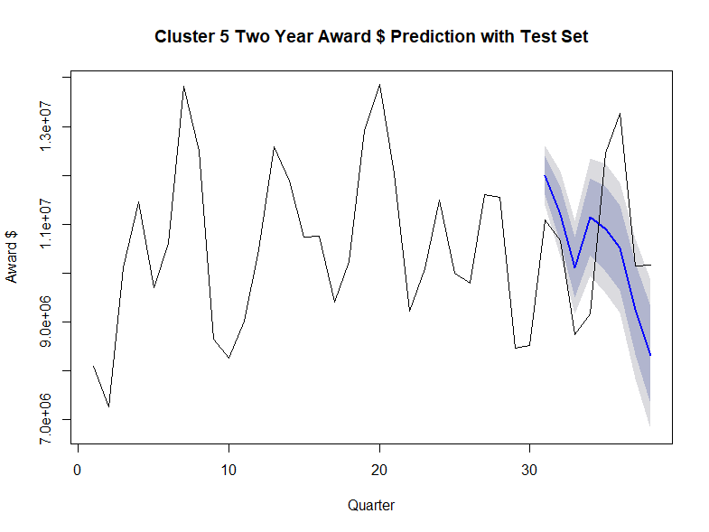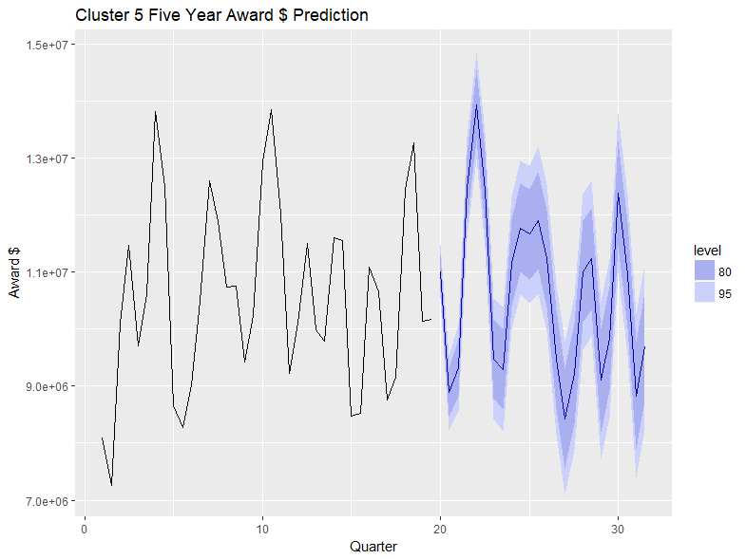

**The Cluster 5 Expenditures forecast** uses **ARIMA(3,2,5)** and has an **MPE of 22.9%**.

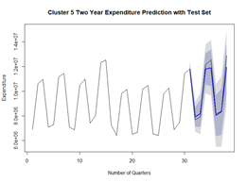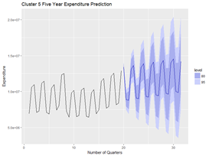

* **Cluster 6:**

**The Cluster 6 Awards forecast** uses **ARIMA(15,1,19)** and has an **MPE of 56.8%**. This data also has r**andom peaks and valleys**, making it **more difficult to forecast**.

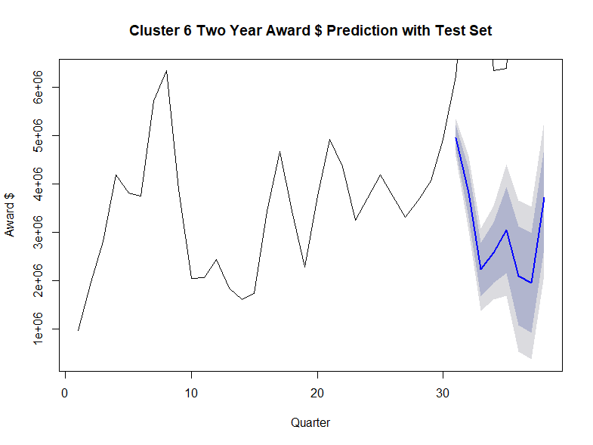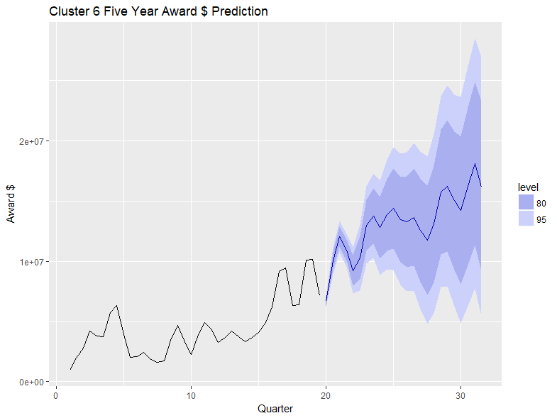

**Cluster 6’s Expenditures forecast** uses **ARIMA(3,0,5)** with an **MPE of 29.9%**

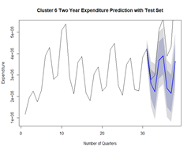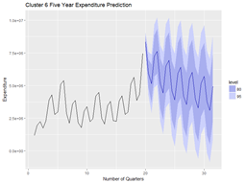

# Conclusion

### Results

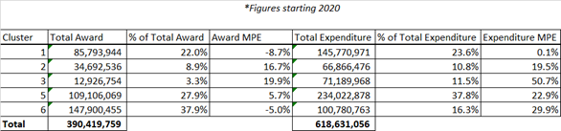

Our forecasting models yielded different results by the different Clusters. Overall, our models perform well, with only the Expenditures forecast of Cluster 3 having a poor error rate at 50%. We see that Clusters 1, 5, and 6 contribute largely to Awards and Expenditures, while Clusters 2 and 3 have a low percent of total for Awards and Expenditures.

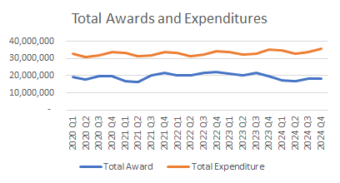

Looking at the patterns of the Awards and Expenditures, they follow similar trends. When Awards rise or dip, Expenditures seem to do the same period or two later. This realization helps us pass a sanity check for our separate models, and indicate that there is a natural relationship between the two. Our relatively low model errors and consistent patterns in Awards and Expenditures give us a positive indicator of our models.

### Insights

The key insight that we discovered in our models is how the different Clusters allowed for our time series models. For example, Cluster 1 had good data patterns for time series, which allowed for an accurate and robust ARIMA model. The Awards $ for Cluster 1 looks pretty good, while the Expenditures has a great dataset for forecasting (the picture on the right shows predictions). Most of the Clusters are stable and robust for forecasting predictions, but some Clusters, such as Cluster 6, has data that make it difficult to accurately forecast. We recommend forecasting the schools based on the Cluster, knowing that each Cluster has different patterns and behaviors. Similarly, one is able to be more secure in the forecasts of certain Clusters, where the data exhibits similar and stable patterns.

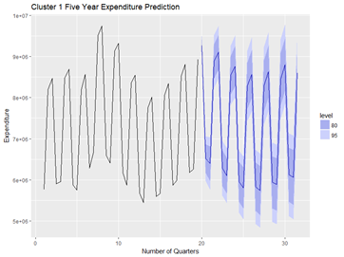

# Awards Capacity

In this section, we look at the data through the lens of Investigators and tried to derive insights regarding Award capacity. In terms of Award capacity, we look at it in three perspectives including efficiency, sustainability and capability.

There are 1049 Investigators in the record with 1036 active Investigators from FY2009 to FY2019, who conducted at least one research project, involved with average 476 active Investigators working on research projects annually. The total Award Amounts generated by individual Investigator are ranged from $300 to $37 million with an average of 1 million. The average Amount per Award generated by individual Investigator are ranged from $300 to $3 million with an average of $0.2 million.

**Efficiency**

Efficiency is defined as the average Amount an Investigator generated from a single Award during the time available in the record. The research period (period) is defined as the fiscal years covered by the current fund effective date (Effective FY) and obligated fund expiration date (Expiration FY). An example of how to calculate the efficiency and period is listed as below.

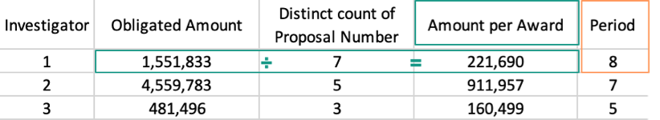

*Efficiency and Period Calculation Explained*

The period was calculated as:

Period = Max(Expiration **FY**)-Min(Effective **FY**)+**1**

After calculating all Investigators’ efficiency and period, we grouped them by their research period and sum up all Investigators’ Amount per Award in the group. This gives us an idea about how each research period Investigators contribute to the university research outcomes. In order to eliminate the case that new joined Investigators don’t have enough time to start their research, we also check the proportion of the project that last within one year and between one to two years. As a result, we found that for research last within one year, 80% of them happened before FY 2018, and for research last between one and two years, 70% of them happened before FY 2017. Thus, we think the effect of short period with the university to research outcome should be minimized.

As below plot showed, we can see Investigators in research period greater than one year and less than four years inclusive are above one hundred Investigators. After the four-year research period, the count of Investigators decreases from 80-100 interval to 20-40 interval, from five-year research period to twelve-year research period. However, on the other hand, the sum of Amount per Award do fall as much as the Investigator counts among different research periods.

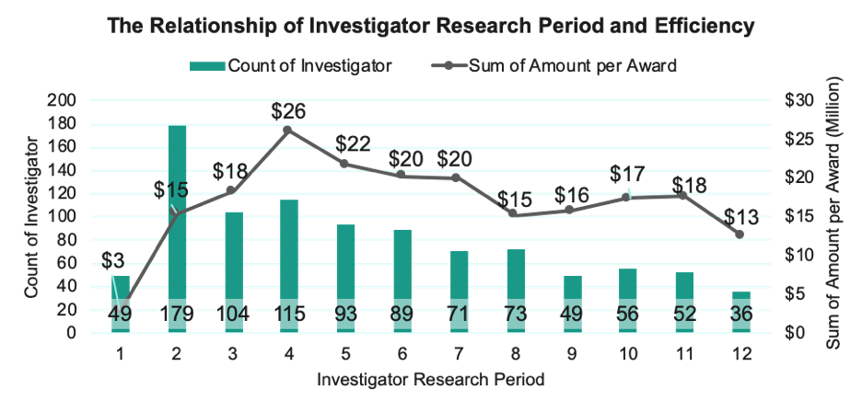

*The Relationship of* ***Investigator*** *Research Period and Efficiency*

After we have the Investigator counts and sum of Amount per Award for each research period, we can calculate Investigator’s productivity. To evaluate each group’s productivity, we take the percentage of each group’s sum of Amount per Award divided by the percentage of total Investigator counts. The equation is

Productivity =% of Sum Amount per Awards % of Count of Investigators

As shown in below plot, it demonstrated an Investigator’s research lifetime and responding productivity. Overall as an Investigator’s research period increases, its productivity increases as well. Thus, we used 100% productivity as a benchmark to separate research periods into three phases, including low efficiency, efficient and high efficiency phases. The low efficiency phase includes research period less than three years, which have productivity lower than 100%; the efficient phase includes research period from four years to six years inclusively, which have productivity about 10% above the benchmark; finally, the last phrase includes period from seven years to twelve years. Additionally, it’s notable that Investigators in the eight-year research period drop their productivity to around benchmark level.

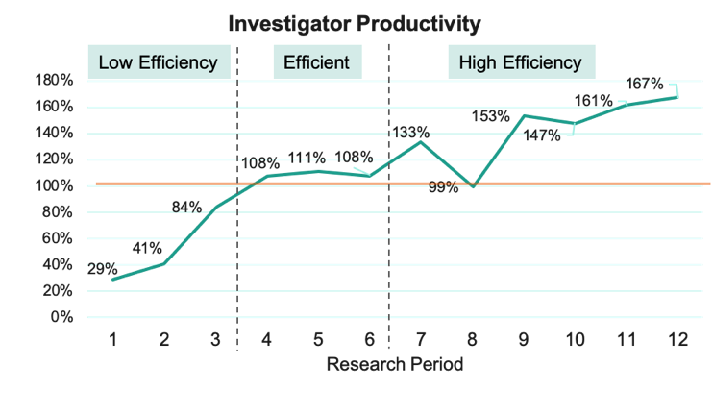

***Investigator*** *Productivity*

**Sustainability**

The second dimension of the Award capacity is sustainability, which is defined as how many fiscal years an Investigator receive new funds during FY2009 to FY2019. Listed below an example of how to calculate years of new funds. Investigator 1 has new Awards in FY2011, FY2012, FY2014 and FY2018, so we count 4 years of new funds for Investigator 1.

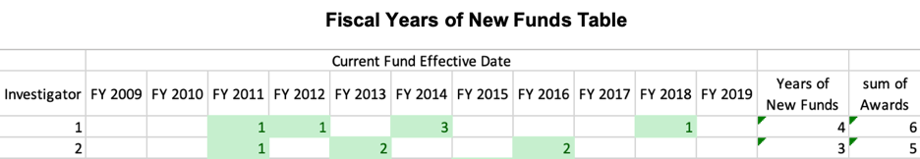

*Fiscal Years of New Funds*

After process above process in all Investigators, we found there are 1004 Investigators generated new Awards during FY2009 to FY2019. As below plot showed, 60% of the Investigators generate Awards in only one or two fiscal years, and this region is defined as low sustainability region. For Investigators who generated only one-year new Awards, 17% of them have more than 5 years research period and 83% of them have 1 year to 4 years research period. For Investigators who generated two-year new Awards, 63% of them have more than five 5 years research period and 37% of them have two to four years research period. On the other hand, there are 13% of the Investigators generated new Awards from six years to eleven years.

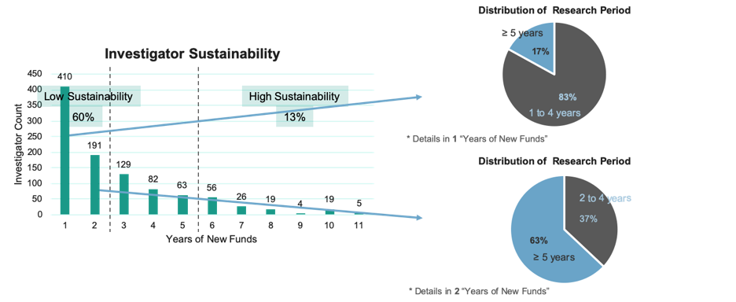

*Investigator Sustainability*

**Capability**

Capability is defined as an Investigator’s ability to manage projects in terms of quality, measured by the maximum Expenditures in a given fiscal year and quantity, measured by maximum projects working in a given fiscal year. Out of total 1049 Investigators, 668 of them have achieved their maximum projects handled and maximum Expenditures at the same fiscal year during FY2009 to FY2019, accounting 63.67% of the total Investigators.

The initial plot is showed as below which includes every Investigators’ project and Expenditures. After we removed all the outliers, including Investigators who have top 4 Expenditures, top 4 projects, zero Expenditures or projects during FY2009 to FY2019. The total outliers are 59 Investigators, and after removing all the outliers, we have 990 Investigators for us to take a further look of their capability.

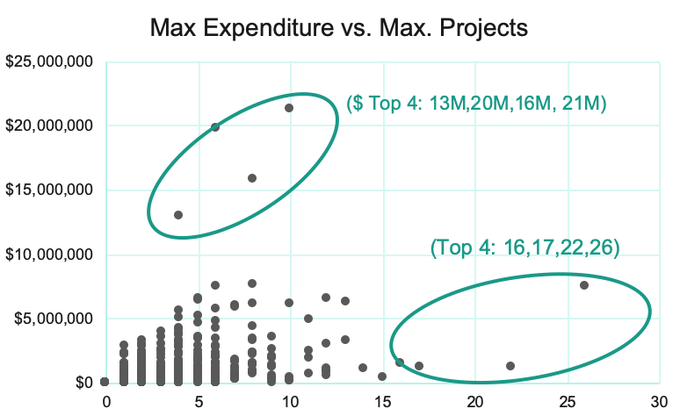

*Max. Expenditures vs. Max. Projects*

After we removed the outliers, we zoomed in to the plot, and divided it into four areas, showed below. Area A includes Investigators who have less than 8 maximum projects handled at the same time with maximum research Expenditures less than $4 millions. Area B includes Investigators who have more than 8 maximum projects handled at the same time with maximum research Expenditures greater than or equal to $4 millions. Area C includes Investigators who have less than 8 maximum projects handled at the same time with maximum research Expenditures less than $4 millions. Area D includes Investigators who have more than 8 maximum projects handled at the same time with maximum research Expenditures greater than or equal to $4 millions. With all 990 Investigators included in below plot, Investigators who fall in area A accounts 1.4% of 990 Investigators, area B accounts 0.7%, area C accounts 93.6% and area D accounts 4.3%.

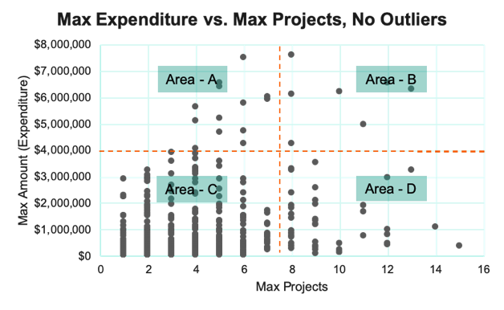

*Max. Expenditures vs. Max. Projects, No Outliers*

**Awards Capacity**

After we look at the Award capacity in three dimensions, including efficiency, sustainability and capability individually, we will look at all the dimensions with the total Amount together by Clustering 1049 Investigators by those features. Below listed five Clusters of Investigators per above features.

There are 572 Investigators in Cluster 1, who have comparatively low in every perspective. In Cluster 2, it includes 73 Investigators who are able to generate new Awards continuously with high total Award Amount by generating comparatively more Awards. In Cluster 3, it includes 48 Investigators who generates comparatively high Award Amounts in total but relatively less quantity of Awards with less frequency. There are 295 Investigators included in Cluster 4, who are relatively medium in all dimensions. Finally, the Cluster 5 includes 16 Investigators who are able to generate the highest Amount of Awards in both total and individual Awards with high frequency and the highest quality of projects handled at the same time.

|  |  |  |  |  |
| --- | --- | --- | --- | --- |
| **Investigators** | **Total Amount (Avg. 1M)** | **Efficiency**  **(Avg. 0.2M)** | **Sustainability** | **Capability** |
| 572 | Low | Low | Very Low | Very Low |
| 73 | High | Medium | Very High | Very High |
| 48 | High | Very High | Low | Low |
| 295 | Medium | Medium | Medium | Medium |
| 16 | Very High | Very High | Very High | Very High |

***Awards*** *Capacity –* ***Cluster (***[*See Appendix for Details*](https://docs.google.com/document/d/1Ag7YSmjYKEDsF23xcRo5AXkZOx2yLlWV/edit#bookmark=id.m39121uxnddo)*)*

# Appendix

* **Trend analysis in Awards Amount versus Expenditures Amount based on the Sponsor type category**

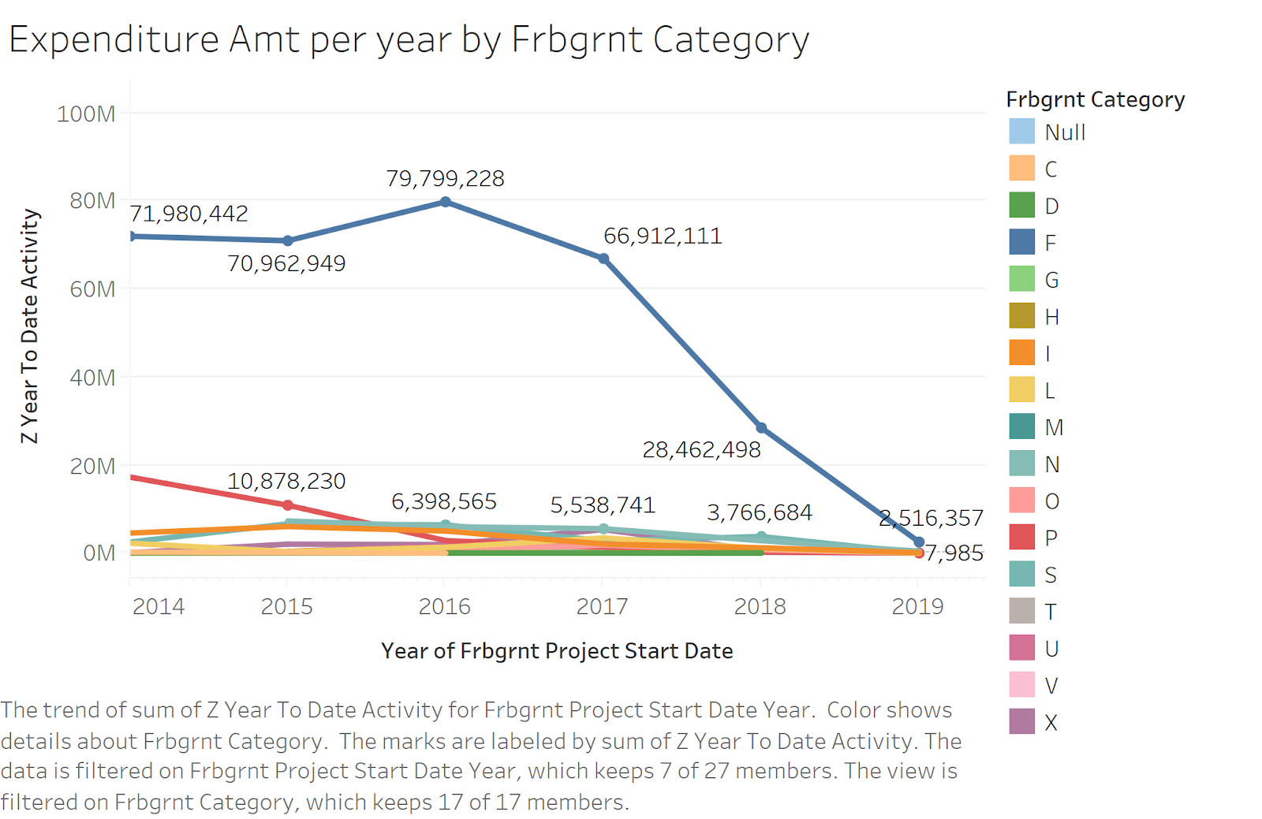

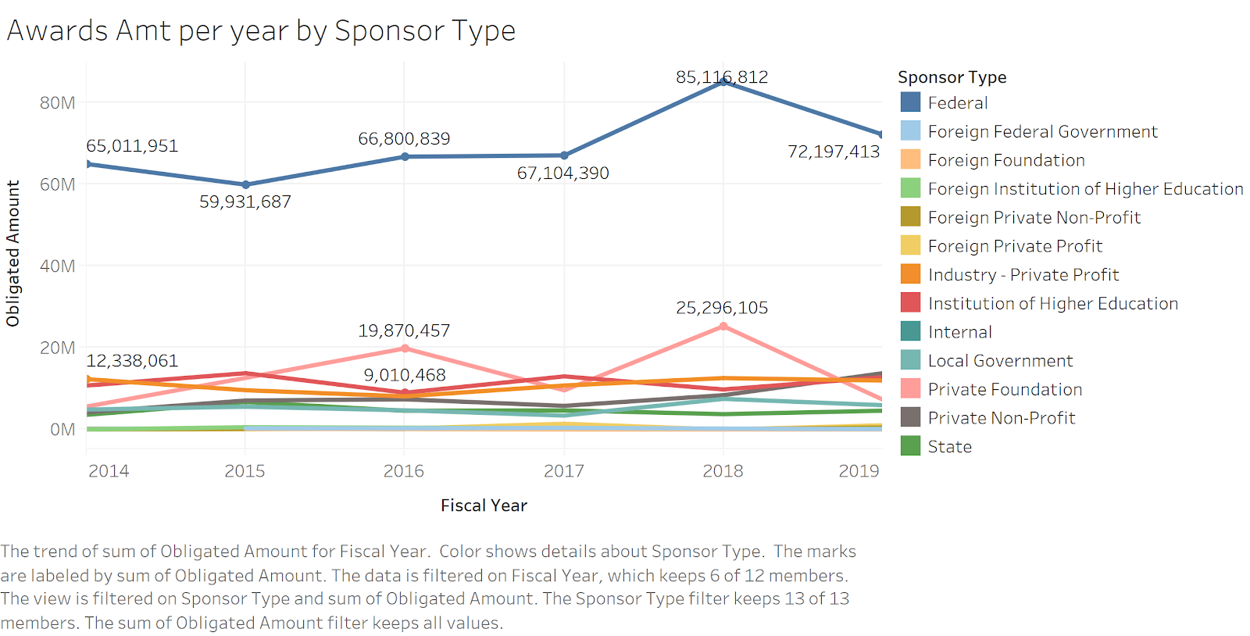

The above Plots shows us how our **Expenditures** is decreasing over the years which is our preliminary question, but the **Awards** through Federal grants and other sources are increasing over time. The trend line in Blue shows us the difference in **Expenditures** and **Awards** for Federal **Sponsor** type

Let’s observe for last **5** years of records the **Expenditures** under federal grant has dropped from **$80** **million** to **$28** **million** in **2018** and the **Awards** funding has **increased** from **$65** **million** to **$85** **million**.

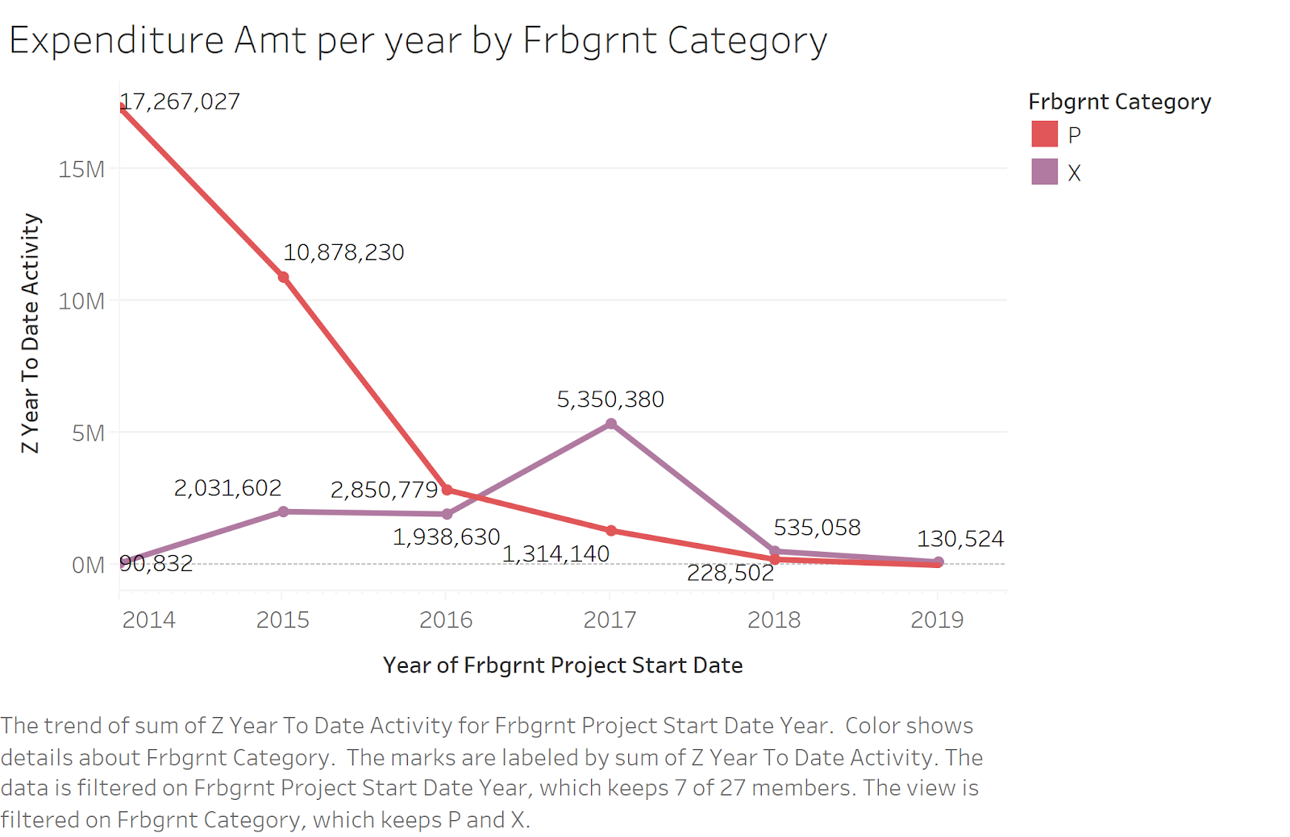

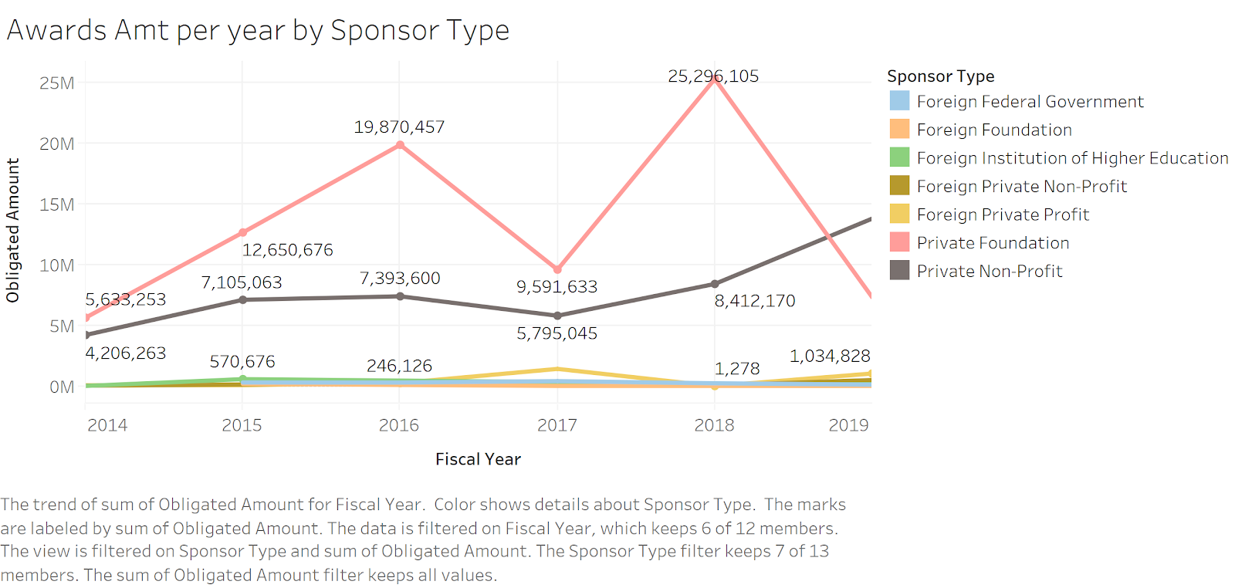

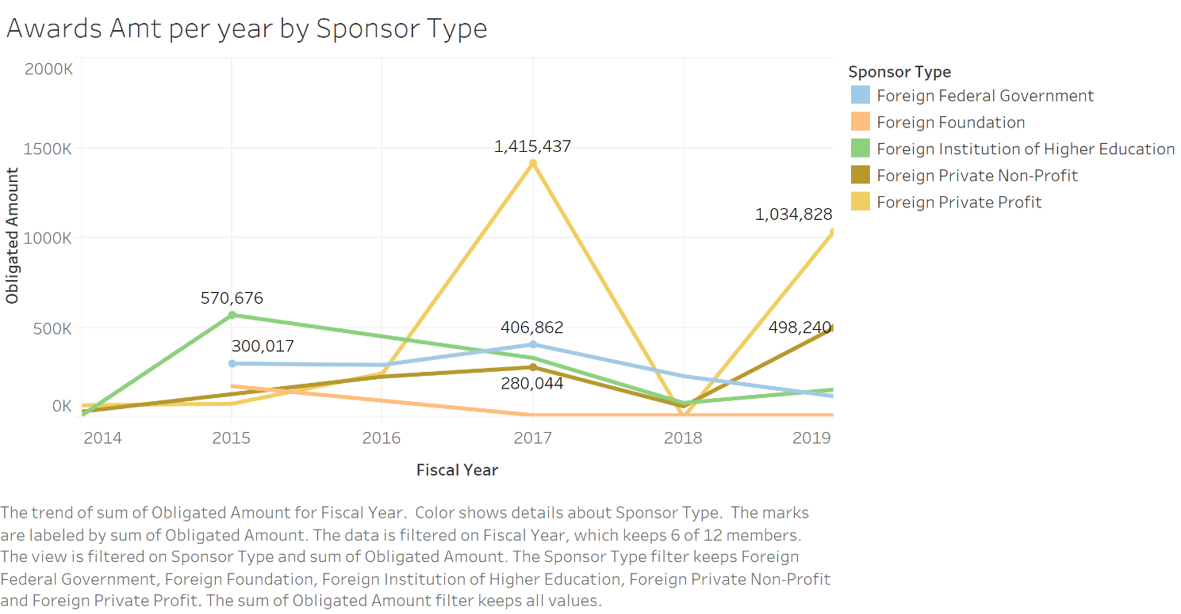

Let’s look at the private and foreign funding and **Expenditures** in the below graphs, where the **Expenditures** has dropped significantly from **$17** **million** to almost **$3** **million** and at the same time the funding from private and foreign sources has an upward trend.

But in case of **Expenditures** for foreign category, the **Expenditures** are going up from **2014** to **2017** and then it's decreasing. the funding tough is increasing over the period but there is a significant drop in funding in foreign category in **2018**.

* **Trend analysis in No. of Proposals Converted to Awards in Each Amount Group**

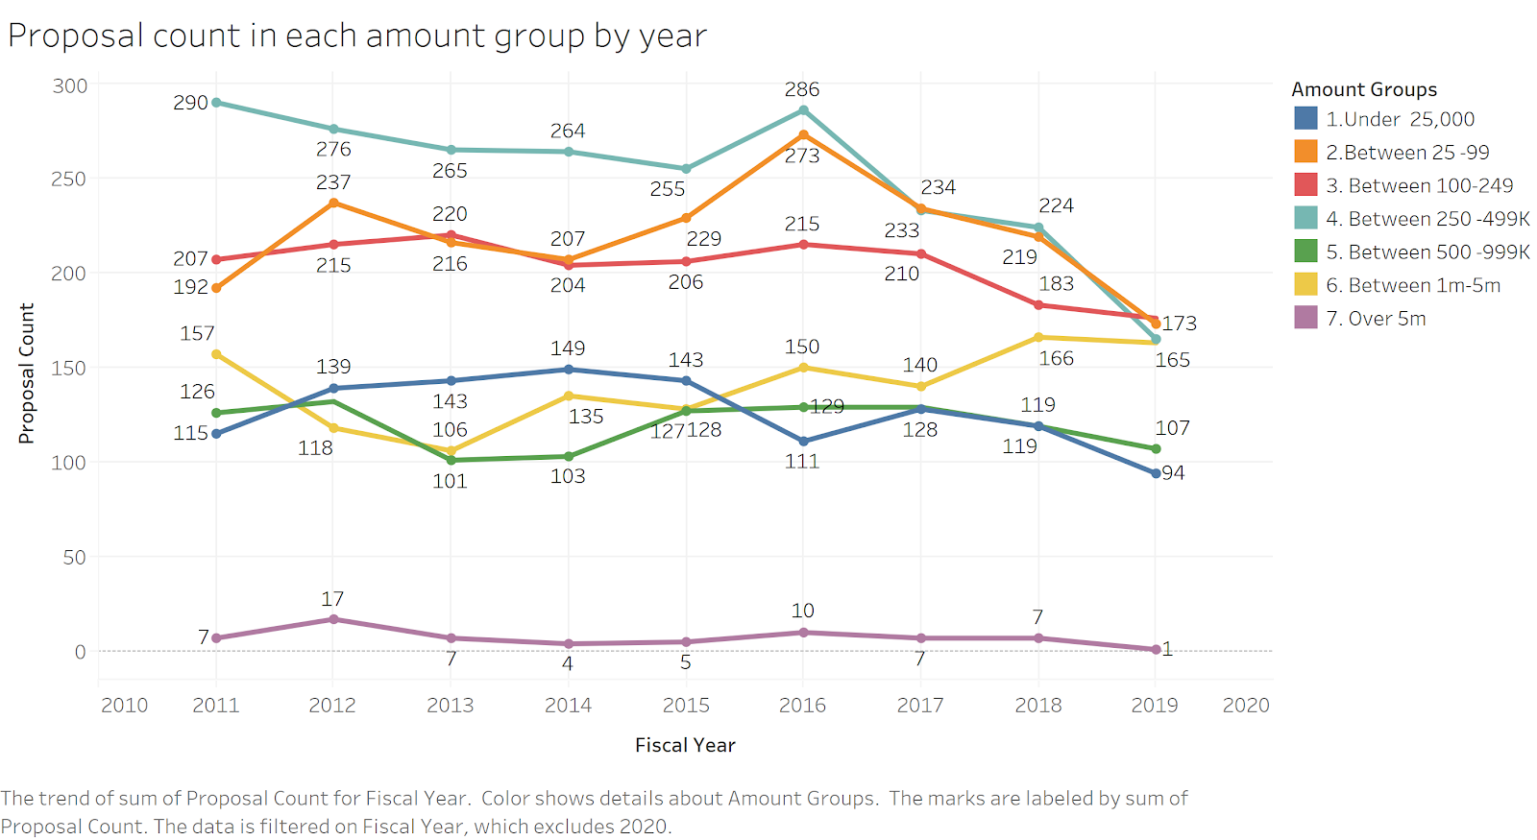 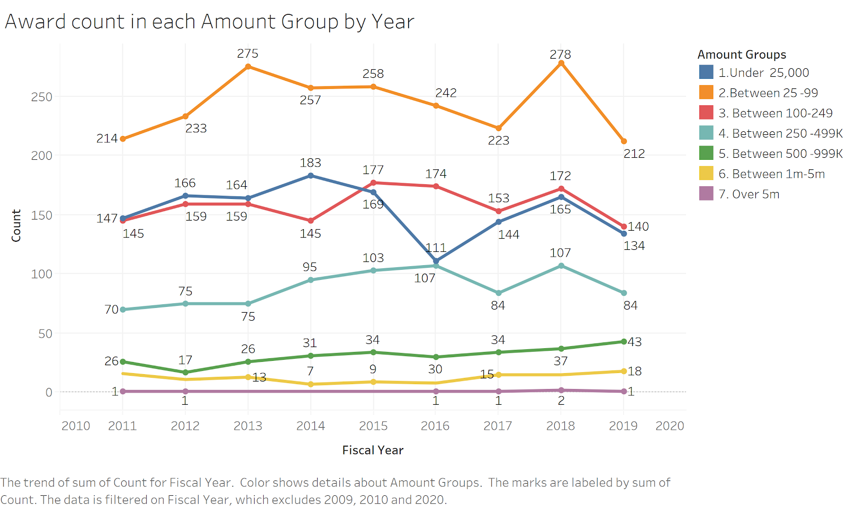

No. of **Proposals** in **Amount** group **5** and **6** are around **100**-**150**+ per year but the **Hit Rate** for them being converted to **Awards** is quite low .ie around **0**- **50** per year

Since group **5** and **6** are the one with high **Amount**s of **Proposals** that makes sense, but you can see an upward trend in both the groups in last few years

This can be one of the reasons why **Awards** **Amount** is increasing

* **Trend analysis in No. of Count and total Amount in each quarterly year for Proposals/Awards/Expenditures**

|  |  |
| --- | --- |
|  |  |

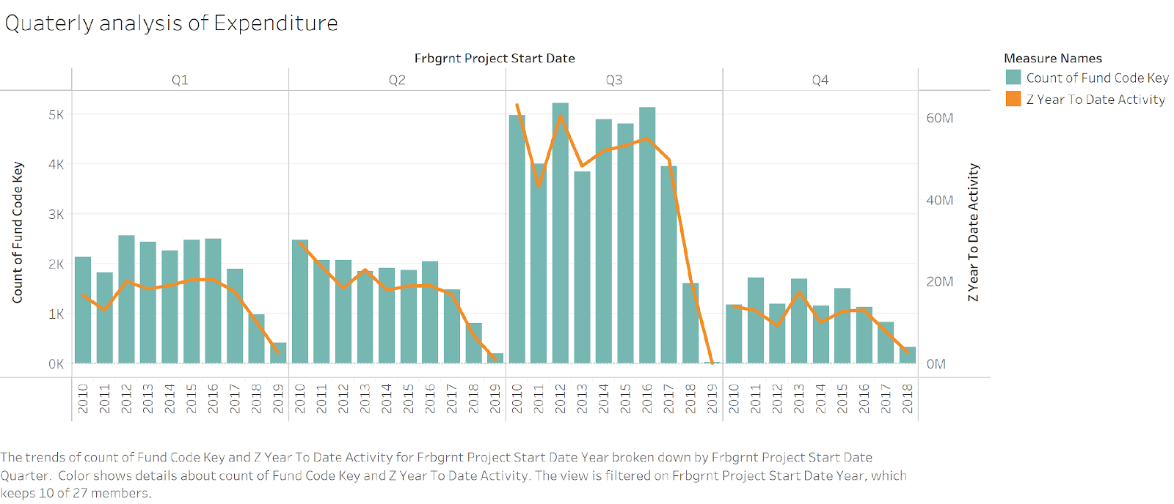

When we further drill down to quarterly analysis of the above data, we can see large no of **Proposals** are made in Quarter **2** & Quarter **3**

Whereas for **Awards** the **Awards** count **increase**s in Quarter **1** and Quarter **4** i.e. in summer

But in terms of **Expenditures**, we can see a clear pattern that the count of records against each **Award** has also **increased** along with the **Expenditures** **Amount**

We would like to study this further that why **Expenditures** in quarter **3** are higher than other quarters. This analysis will also help us understand why overall **Expenditures** are low.

* **Forecasting Results for Awards**

**Awards $ - Cluster 1**

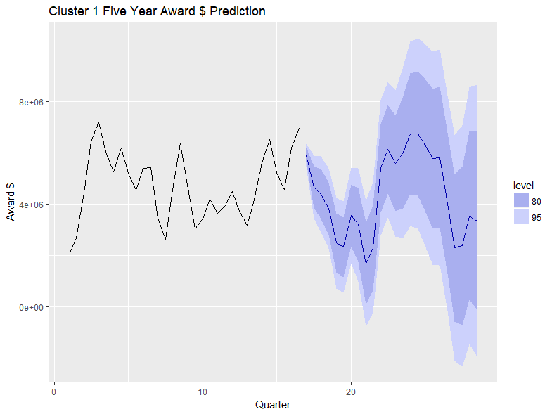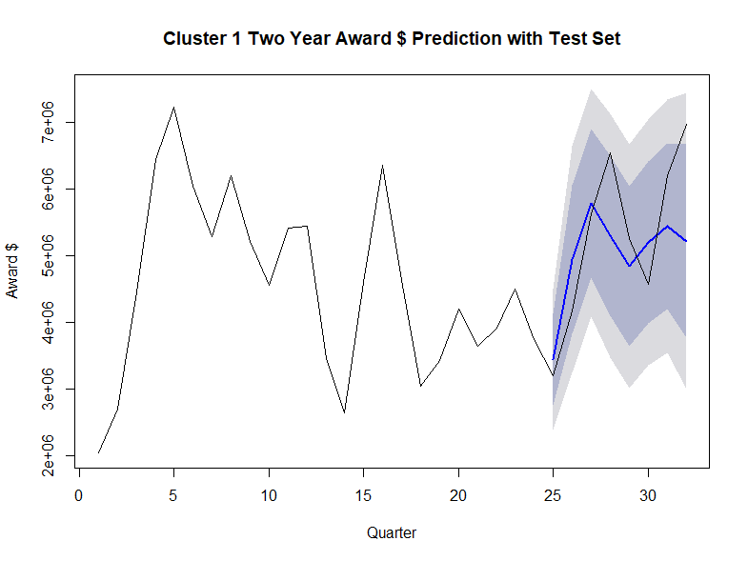

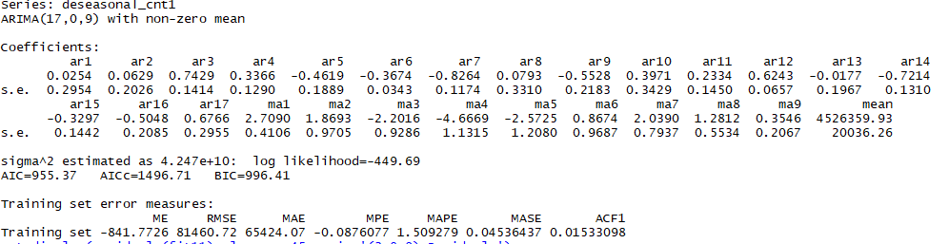

**Awards $ - Cluster 2**

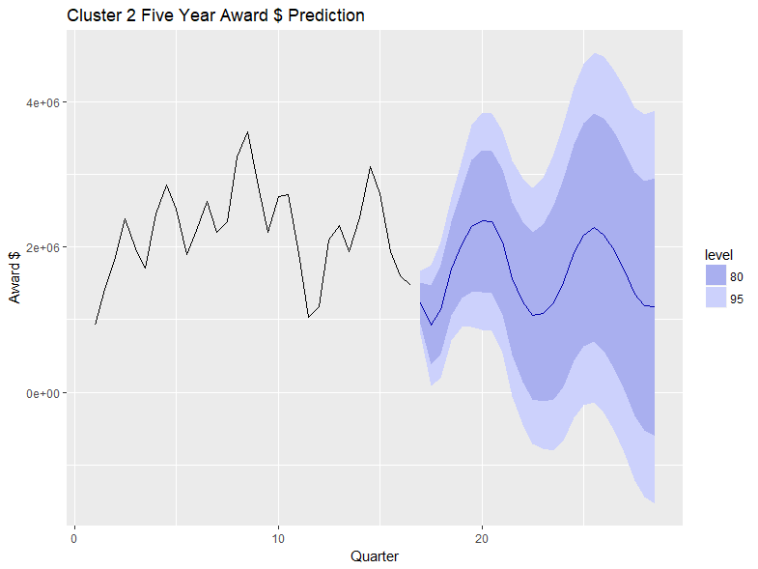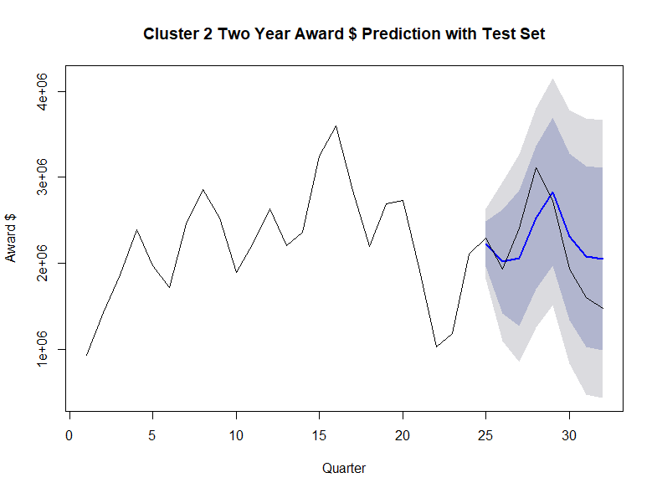

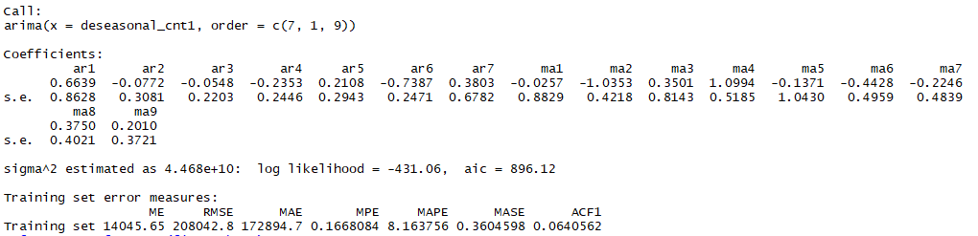

**Awards $ - Cluster 3**

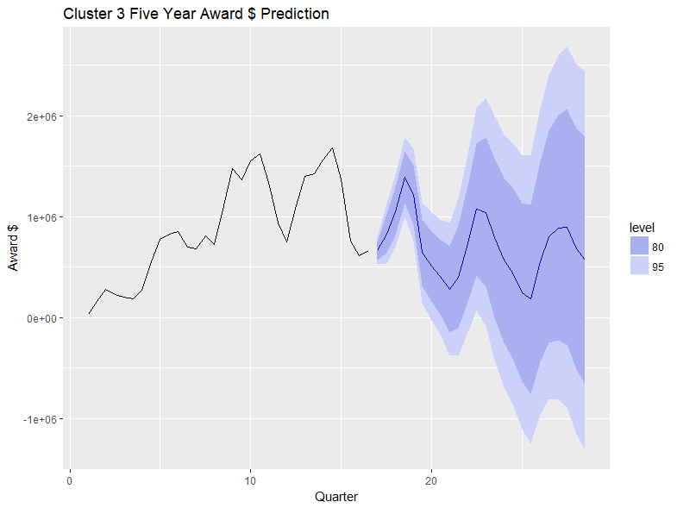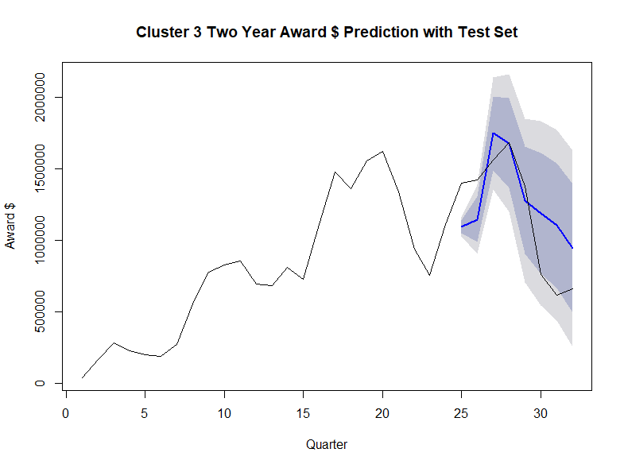

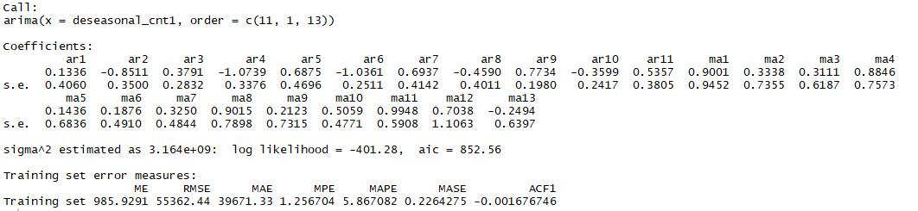

**Awards $ - Cluster 5**

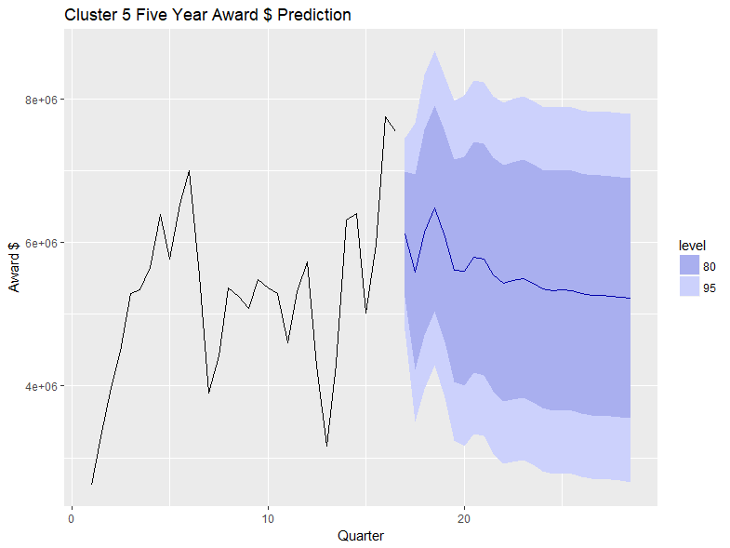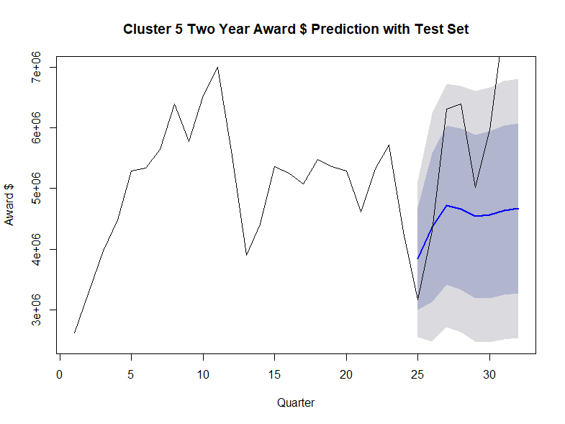

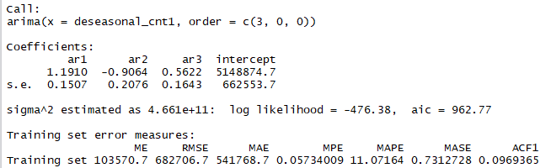

**Awards $ - Cluster 6**

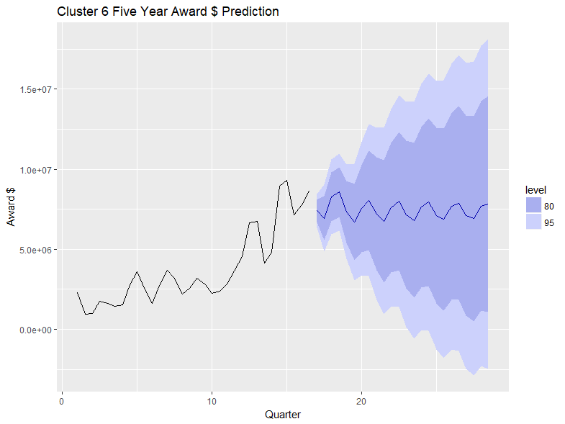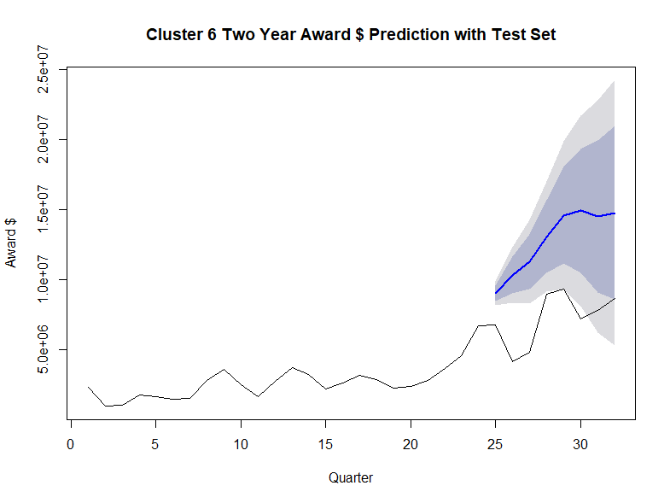

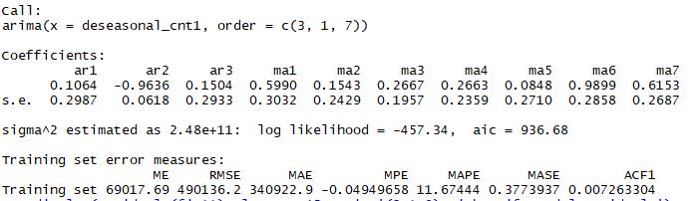

* **Forecasting Results for Expenditures**

**Expenditures $ - Cluster 1**

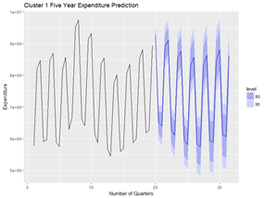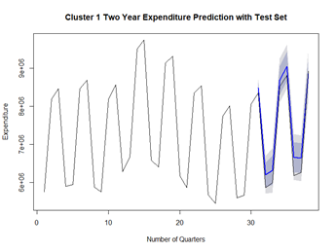

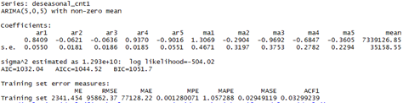

**Expenditures $ - Cluster 2**



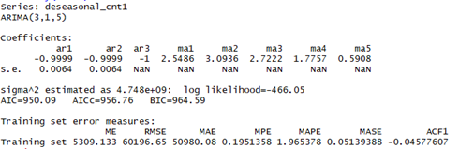

**Expenditures $ - Cluster 3**

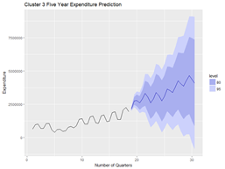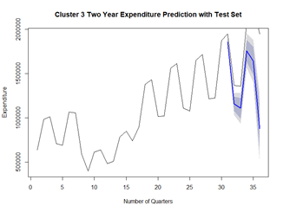

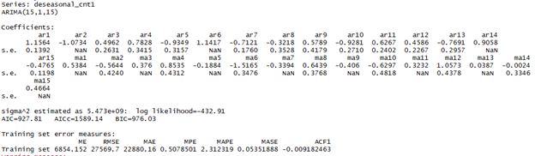

**Expenditures $ - Cluster 5**

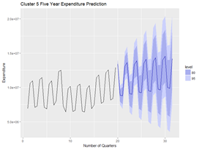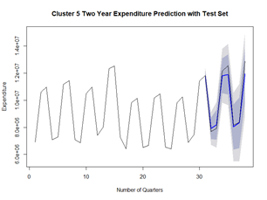

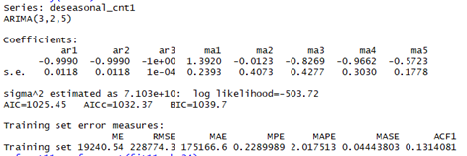

**Expenditures $ - Cluster 6**

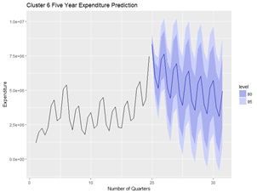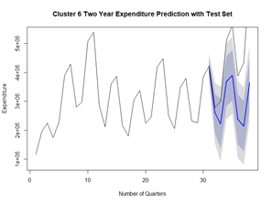

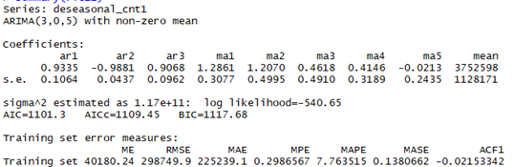

# References

1. **Power BI** **Dashboard:**
2. [https://app.powerbi.com/view?r=eyJrIjoiODZhNWFjMjctMTljYy**00**MWIyLTliYzUtOTUxODUwYzEyZmJkIiwidCI**6**IjBhNzg**0**MTQ**2**LTU**4**MTYtNDhjMi**1**iODk**5**LWY**0**NTRiMzI**5**NDFhZSIsImMiOjF**9**](https://app.powerbi.com/view?r=eyJrIjoiODZhNWFjMjctMTljYy00MWIyLTliYzUtOTUxODUwYzEyZmJkIiwidCI6IjBhNzg0MTQ2LTU4MTYtNDhjMi1iODk5LWY0NTRiMzI5NDFhZSIsImMiOjF9)
3. [https://app.powerbi.com/view?r=eyJrIjoiOWRiN**2**U**0**NmMtMmE**5**NC**00**NjhlLWFjZjYtMzAwYmUwZDcyYWM**1**IiwidCI**6**IjBhNzg**0**MTQ**2**LTU**4**MTYtNDhjMi**1**iODk**5**LWY**0**NTRiMzI**5**NDFhZSIsImMiOjF**9**](https://app.powerbi.com/view?r=eyJrIjoiOWRiN2U0NmMtMmE5NC00NjhlLWFjZjYtMzAwYmUwZDcyYWM1IiwidCI6IjBhNzg0MTQ2LTU4MTYtNDhjMi1iODk5LWY0NTRiMzI5NDFhZSIsImMiOjF9)
4. Top **100** Worldwide Universities Granted U.S. Utility Patents in **2017**, National Academy of Inventors
5. National Science Foundation, Higher Education Research and Development Survey, [https://ncsesdata.nsf.gov/herd/**2017**/](https://ncsesdata.nsf.gov/herd/2017/)
6. The Center for Measuring University Performance at the University of Massachusetts Amherst and the University of Florida, The Top American Research Universities annual report **2016**, **2017**
7. Northeastern University, <https://research.northeastern.edu/nu-res/>
8. CRS analysis of National Science Foundation, National Patterns of R&D Resources: **2016**–**17** Data Update, February **27**, **2019**, [https://ncses.nsf.gov/pubs/nsf**19309**](https://ncses.nsf.gov/pubs/nsf19309).
9. “Message from the Senior Vice Provost for Research.” Office of Research, **Drexel**.edu/research/about/message/.